2025
ID Integration Inc.

10/30/2025

Prescott AZ Guide for AssetWorx! 4.0.8.7

TABLE OF CONTENTS
- Running ADHOC 1
- How to Use Offline Printing Station 1
- How to Connect Zebra Sled 1
- How to Install AssetWorx! to a Zebra Sled 1
- Using Web Services Mode on AssetWorx! VA Mobile Application 1
- How to Use “Locate” Feature on Zebra Sled Reader 1
- How to Adjust Power on Zebra Sled Reader 1
- Missing Location Tag: What do I do now? 1
- AssetWorx! VA Mobile Application Pink Asset Help: How to add to your location 1
- How to Use the Logout Feature on Zebra Sled Reader 1
- How to Get ENNX Report to Update Assets in AEMS/MERS 1
- How to use Batch Mode Scanning 1

Running ADHOC
- Run AdHoc in Above PAR report to create the “EQUIPMENT.xlsx” excel sheet template with desired EE tag information.
Below is the precise AdHoc Field Selections and Order number needed to pull this Report.
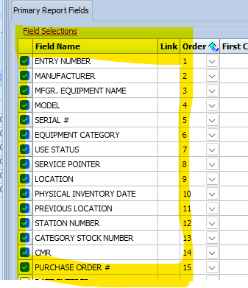
Example A: By putting in First Condition with EE number you will only pull that EE number. If you put in a Second Condition with EE number it will pull Two EE numbers. If you do not put any conditions, it will pull every EE number in the system.
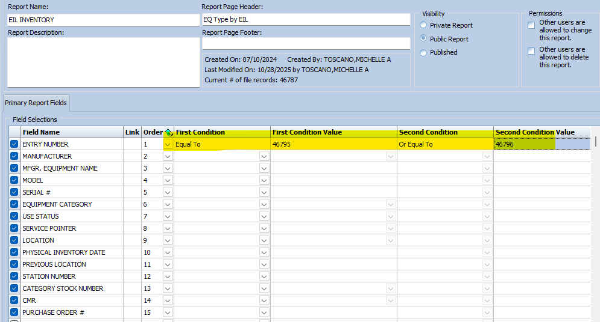

Example B: First condition as Greater Than, and the EE number before the EE number you want through to the last created EE number. (if you want to start at EE46795, put in EE46794)
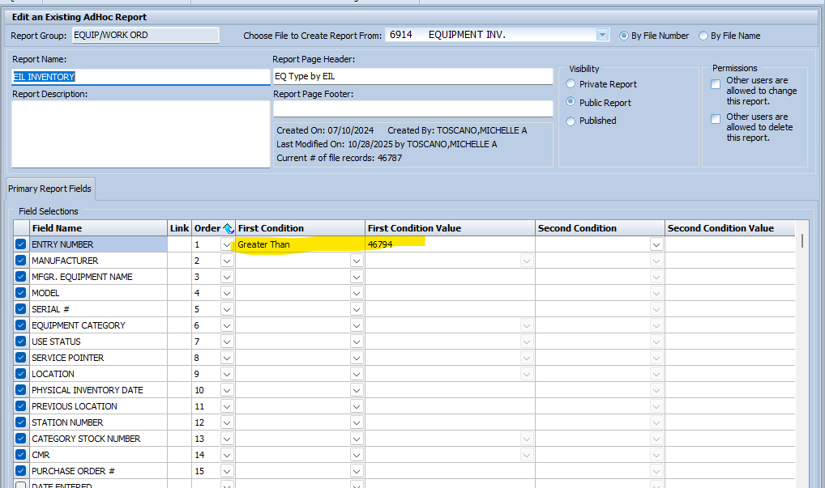

Example C: If you need to pull EE numbers by Date Entered, add Date Entered Field Selections, add First Condition as Equal to and the date you created the Equipment. However, after you pull the report in excel you MUST Delete the Date Entered Column before emailing it to V22649@id-integration.com!
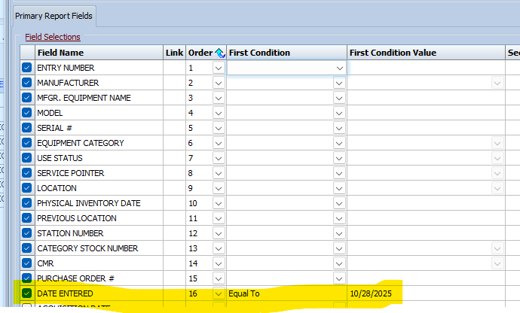

After running the AdHoc report Click on Excel, this will be the excel you will e-mail. 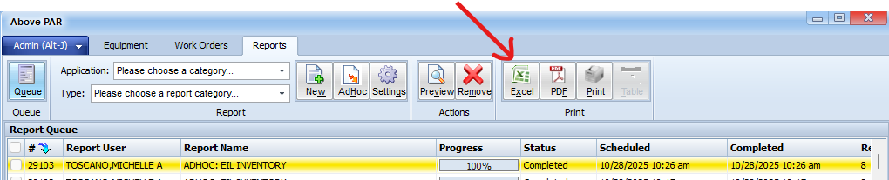

Or Click on Preview to check what was pulled first, then click on Excel
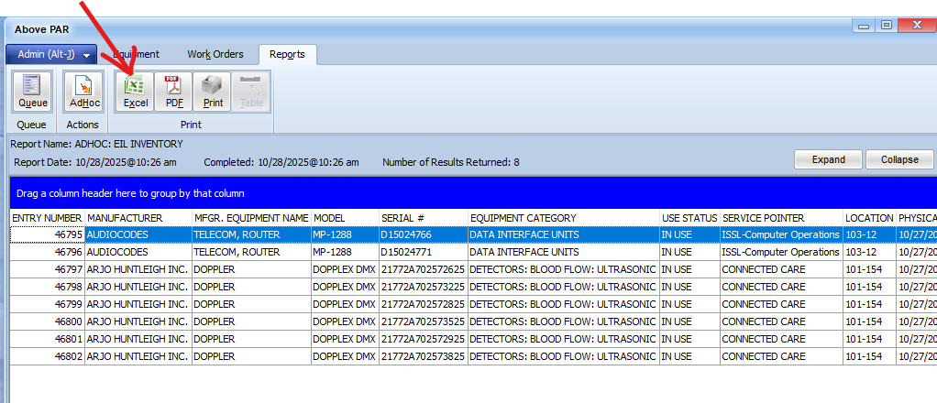

On the Excel, change tab name to SHEET1, Chang and save file name as EQUIPMENT.XLSX
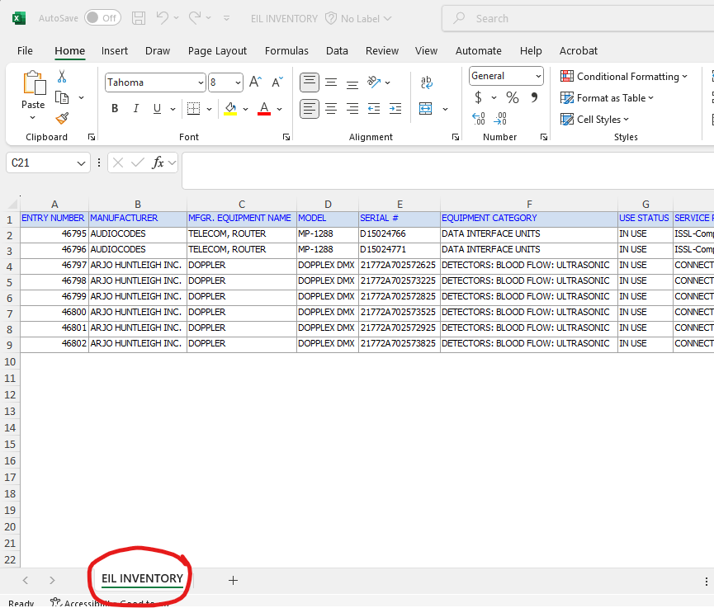
Now you are ready to Send an email to V22649@id-integration.com and attached the Excel you just created.

How to Use Offline Printing Station

- Go to the printing station and open Microsoft Outlook.
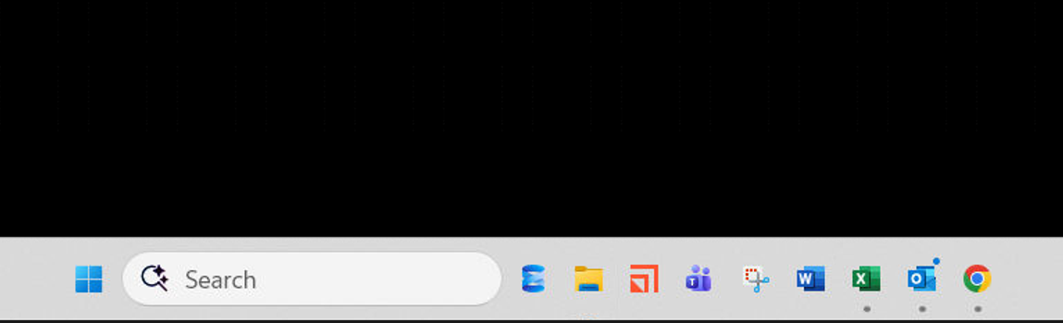

- Select the new email and click on the dropdown arrow - select “Save As” as in the example below
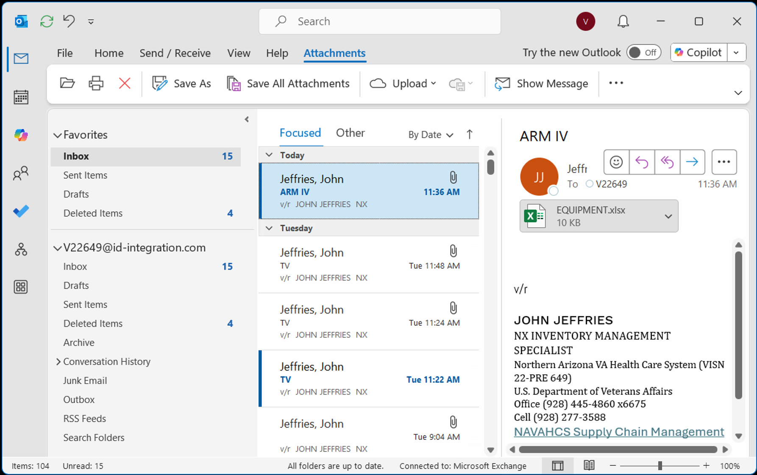

- Next, find and click on “Local Disk (C:) VA_RFID PRINTING” There is a shortcut for your convenience on the desktop. We will use “Email Printing” as the example here.
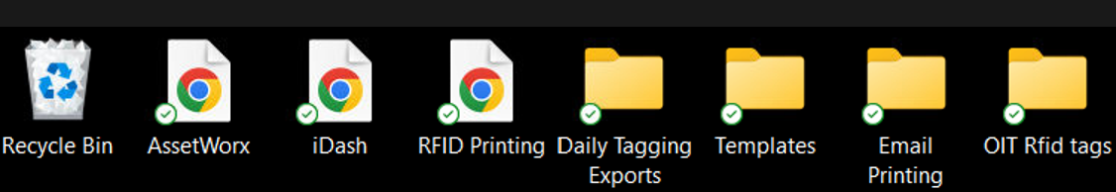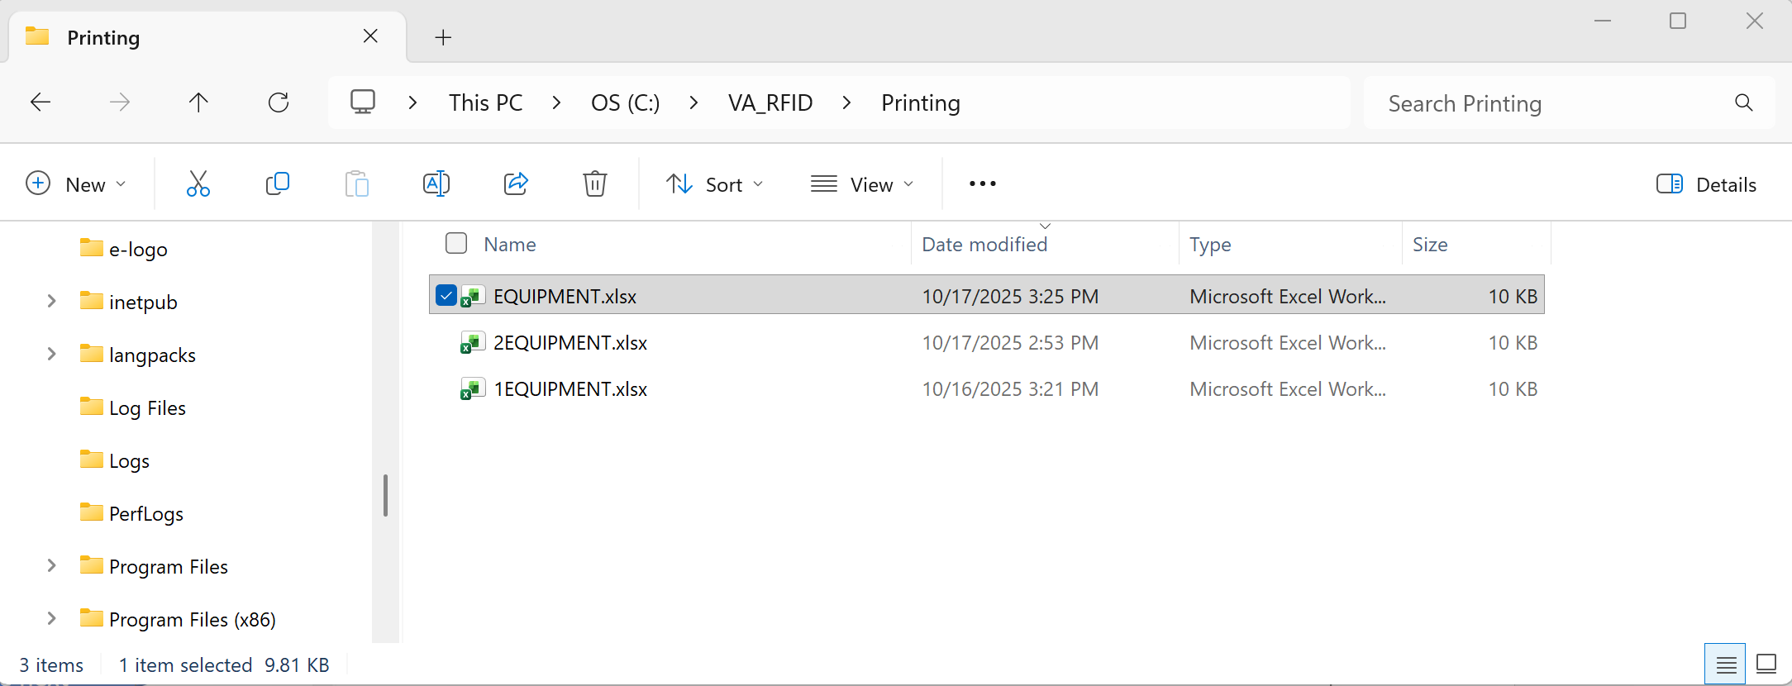
This existing file with the same name will get renamed in the next step.

  - You must save this file as “EQUIPMENT.xlsx” for the template to print correctly.
  - Rename or delete any existing file with the name “EQUIPMENT.xlsx”
Just a reminder there can only be one file named “EQUIPMENT.XLSX” in the folder. Rename any others.
Now you can save the new “EQUIPMENT.xlsx” file.
- Open “RFID Printing” by selecting the application icon in the Desktop as shown in the example below
- 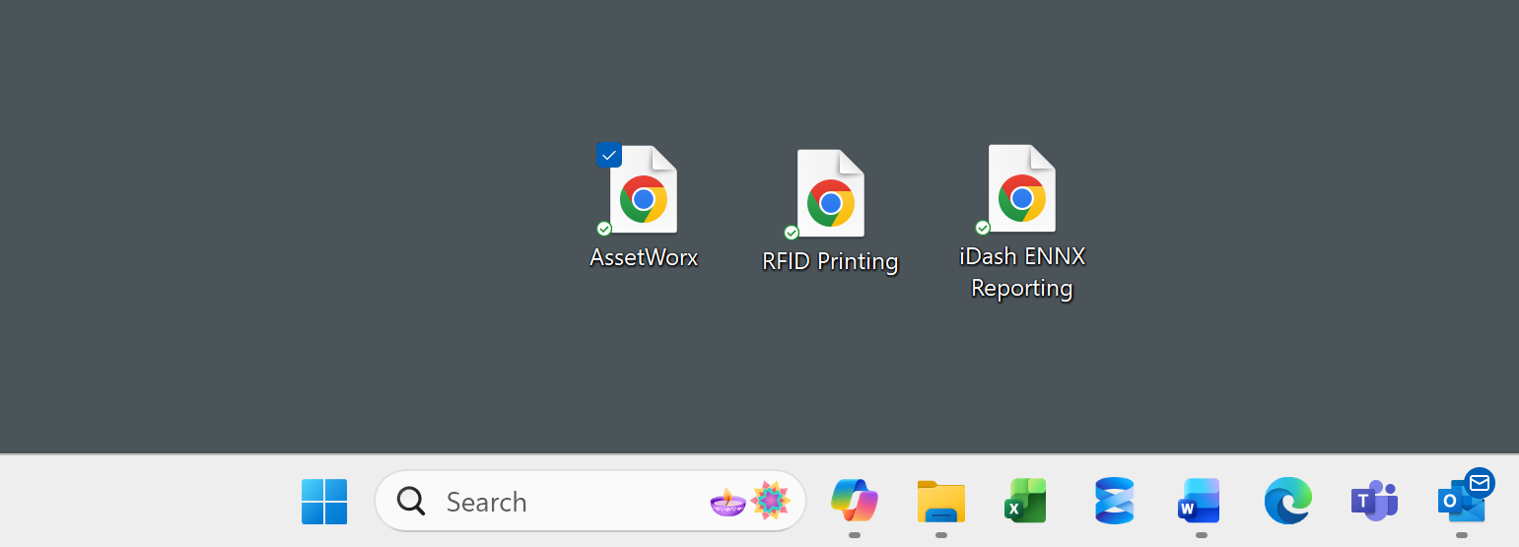

** Prescott currently has 3 printing categories to accommodate different situations.
- Daily Scans Tagging (Scanning equipment for inventory or for EIL Locating)
- Email Labels (Items created by users and emailed to print station to be printed)
- Supply Chain (Reprint labels)

- Once open, click on a category. In this example we will use “EMAILED LABELS”.
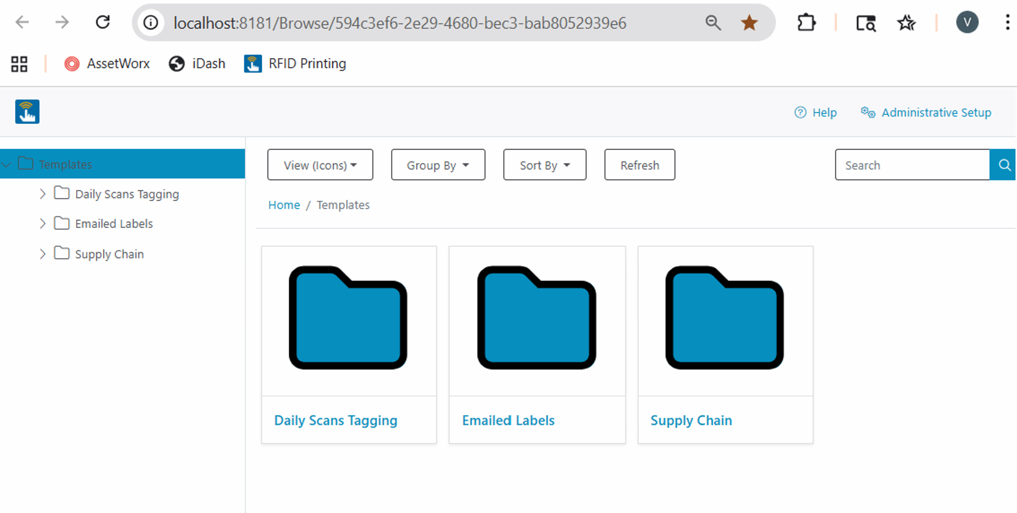
- You will now see 4 label options to choose from. Large_Excel, Small_Excel, Std_Small_Excel, and Q350_Excel.

Choose your desired tag type and click on it. In this example we are going to select Large_Excel label to print. Click on Large_Excel.

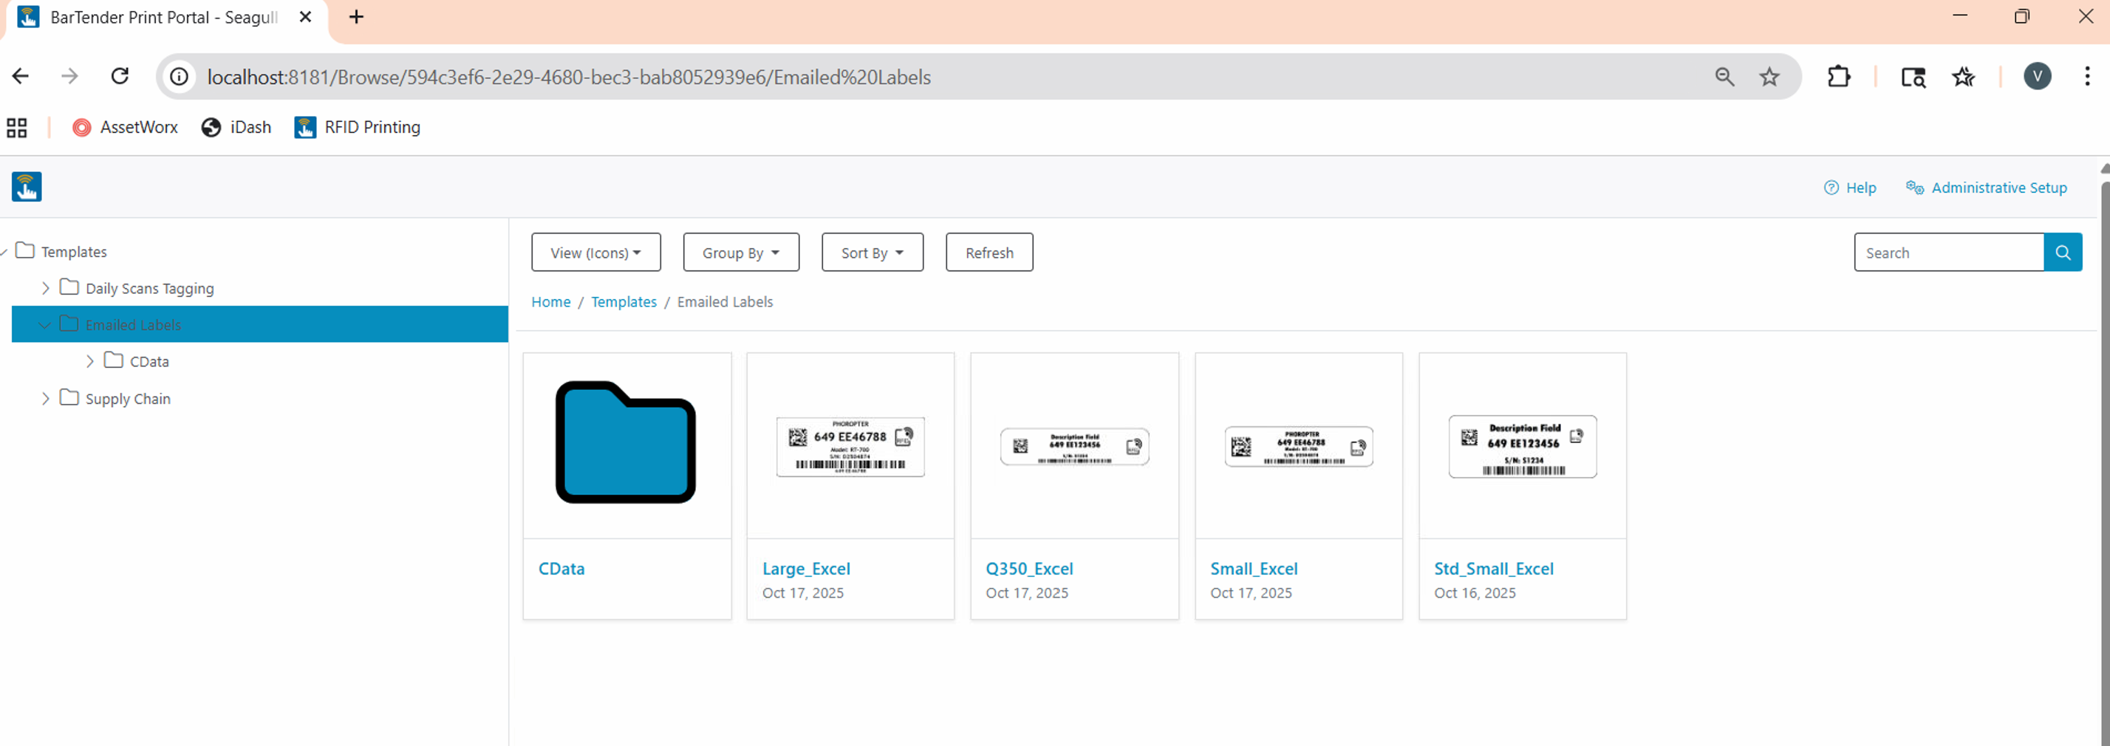
*Note that Std_Small is thin

- Next you will see a screen displayed like in the example below. Click “Print”
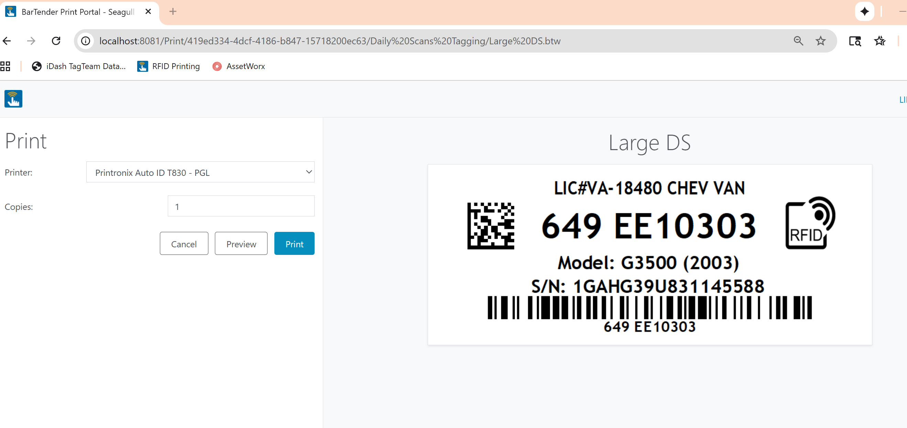
- Select items you would like to print by checking the box to the left as shown in the picture below. Alternatively, you can print all by selecting the top box. Next click “Print”
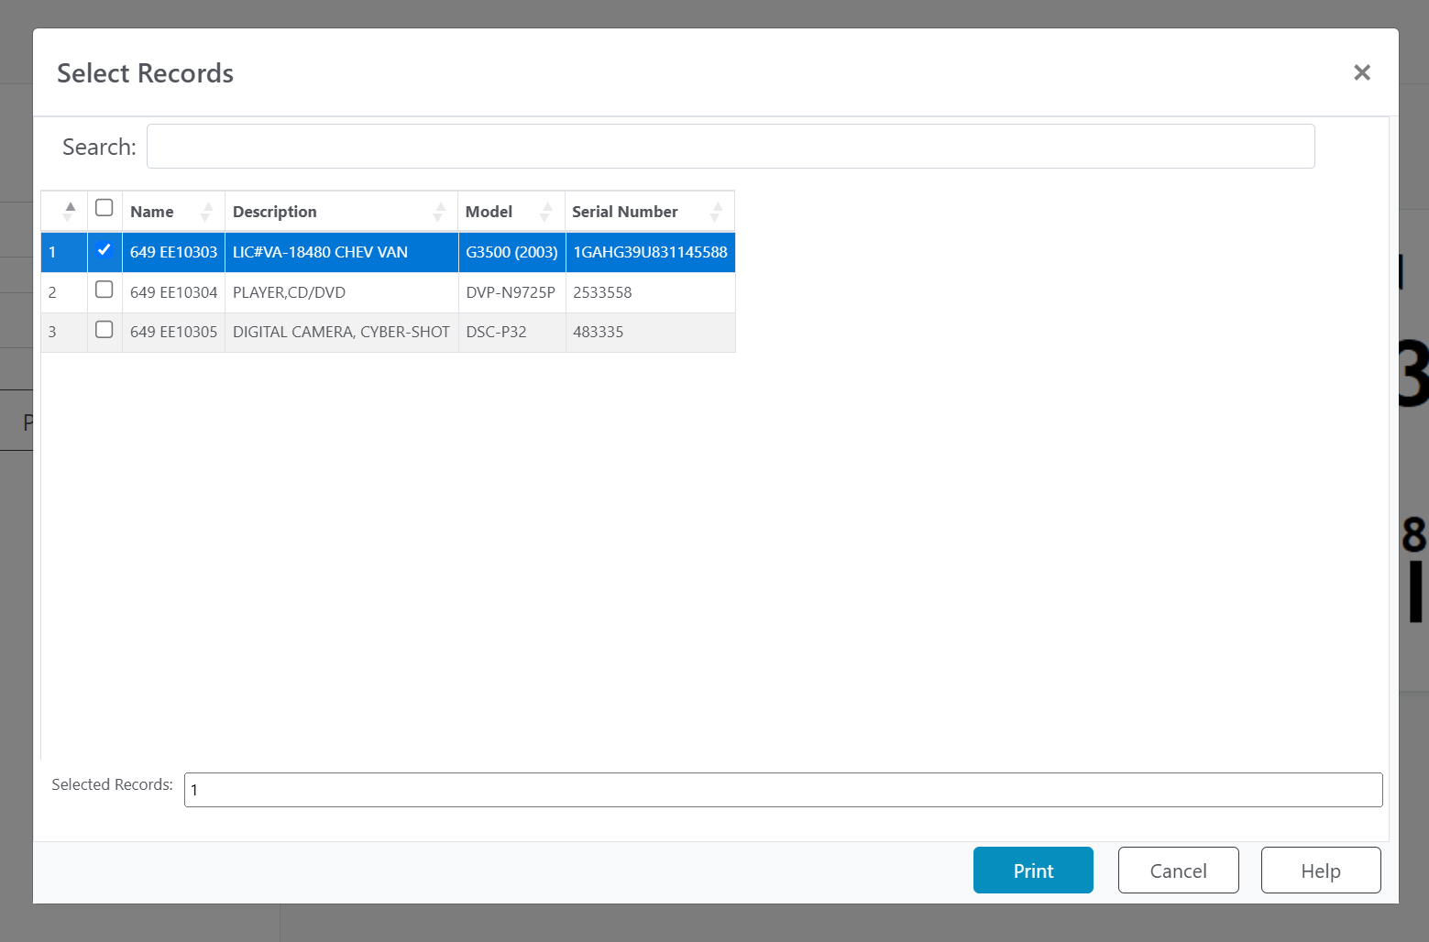
- Apply the laminate on to your label using the overlaminates provided for each tag type.
- After printing, if you would like to print a different tag type, click “Close”, and then click “Cancel”.
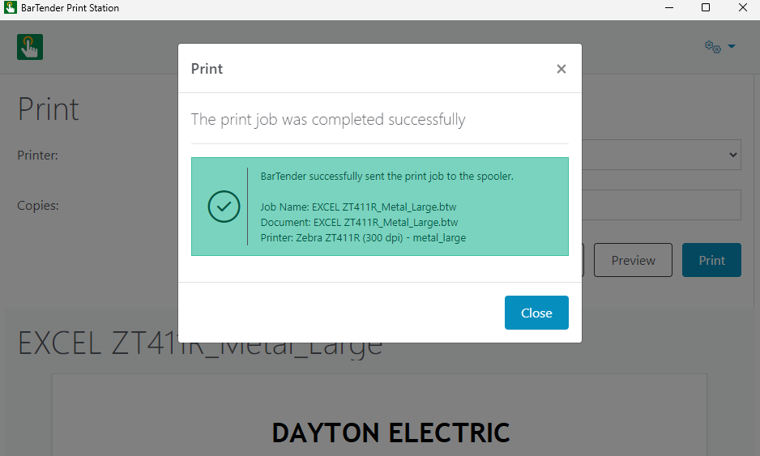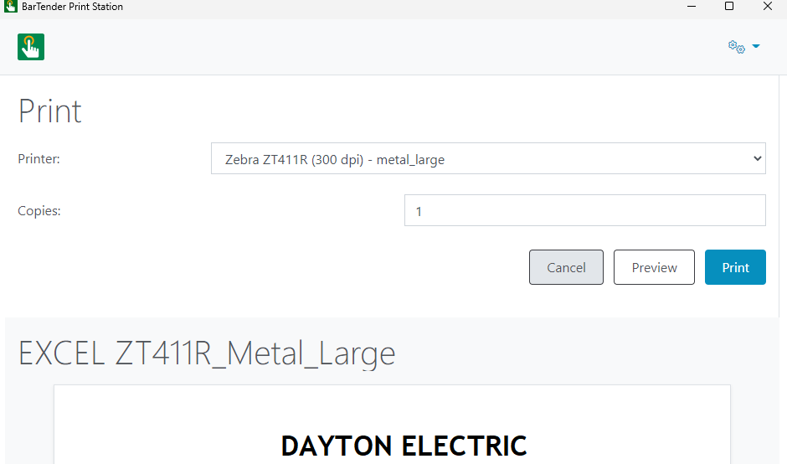
- After selecting cancel you will be brought to the page seen below where you select the next tag type to print.
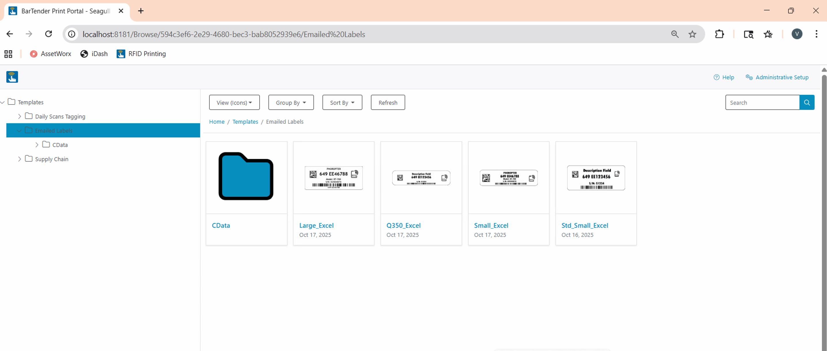
This process continues for each category of printing you will use.

How to Connect Zebra Sled
For AssetWorx! VA to work correctly, make sure the site laptop used to print, and the TC53 RFID reader are connected to your vendor provided MiFi wireless network. Also, make sure the Zebra Sled is connected via Bluetooth.

Follow these instructions to connect Wi-Fi and make sure you are ready to use AssetWorx! VA

Settings
Select Settings on Home Screen. Settings Screen
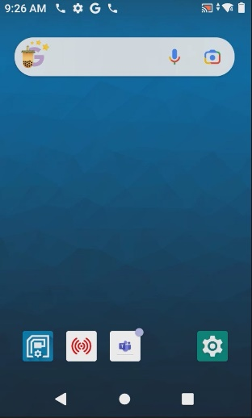
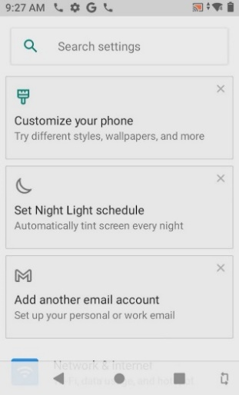
Initial settings screen will be presented
Settings menu will be used to configure many different items

Scroll and click “Network & Internet” Select “Wi-Fi”
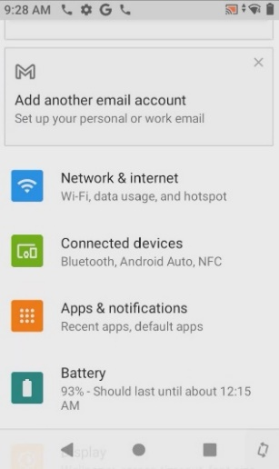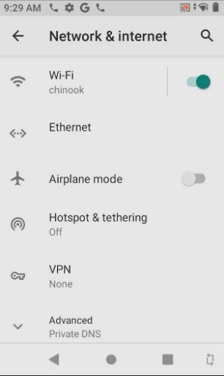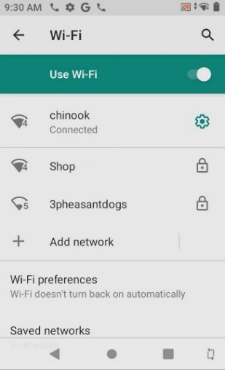
Your MiFi device will have a name like “Franklin” or “Verizon”. Please call support if you have questions or problems locating it
Scroll up to see “Network and Internet” settings
Find and choose your network to connect. The Wi-Fi network used at the VA is called “Verizon”

Bluetooth
Select “Connected devices” Saved devices
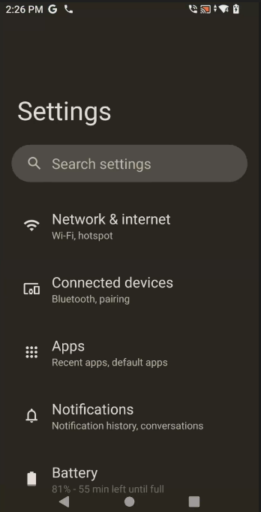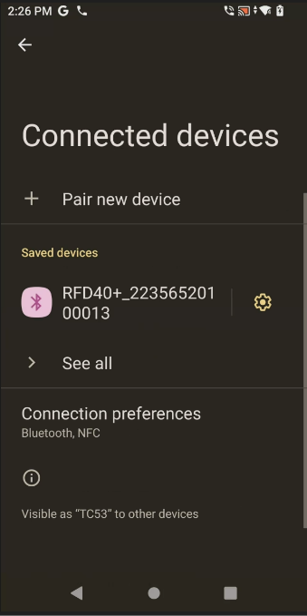
If your device is already connected you can continue to the next page of this document. You will know it is your device if the last 4 digits match the S/N of your Zebra Sled. “0013” in this example.

Click on, “Pair new device”
If no device is connected
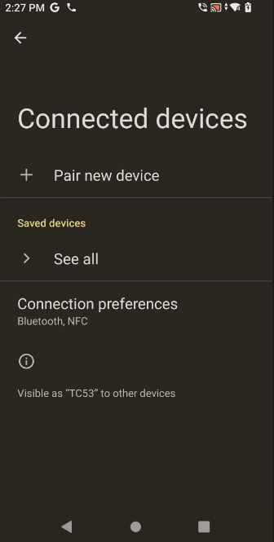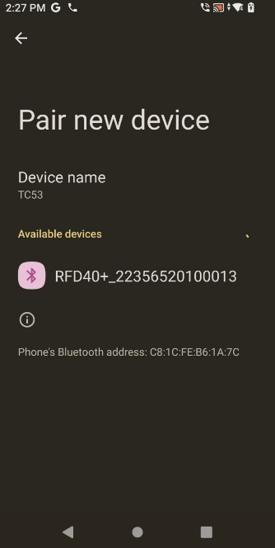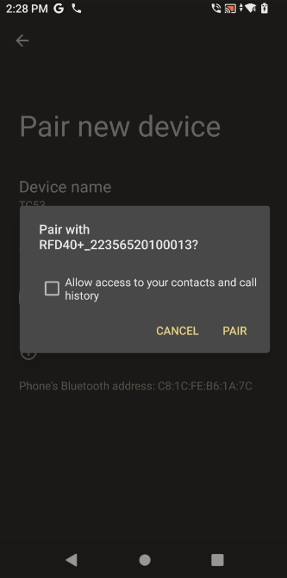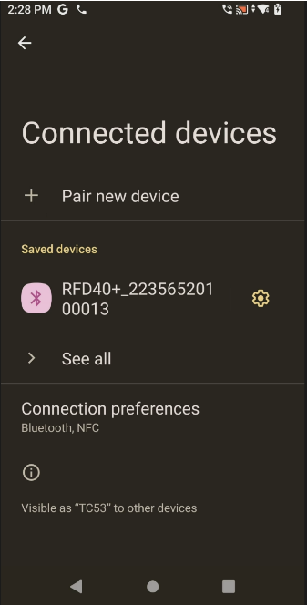
Once it is paired, you will see it under, “Saved devices”. Continue to the next page of this document.
Squeeze the trigger on the Zebra sled and wait for it to pop up under, “Available devices”, then click on “PAIR”.

After confirming that your RFID Sled is under “Saved devices” you may move to the next page of this document.
- Open the AssetWorx! VA application. The icon looks like this example.
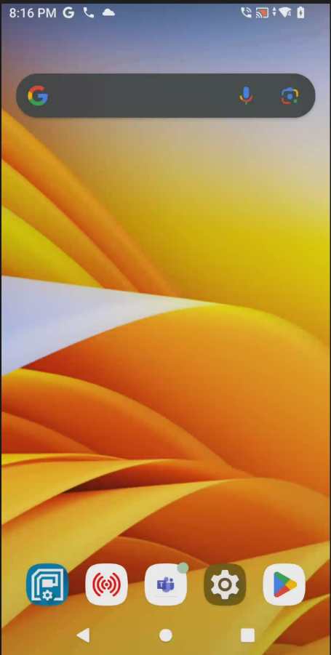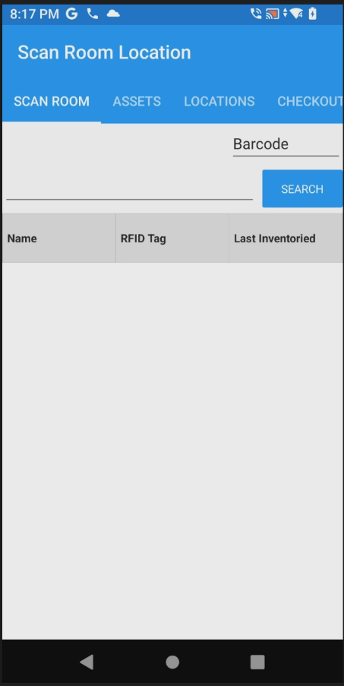
If you hear 2 beeps and the Bluetooth icon is lit up blue on your RFID Sled, your reader is connected. If you do not hear 2 beeps, continue to the next step.
- Scroll over to More and select “CHOOSE SCANNER”.
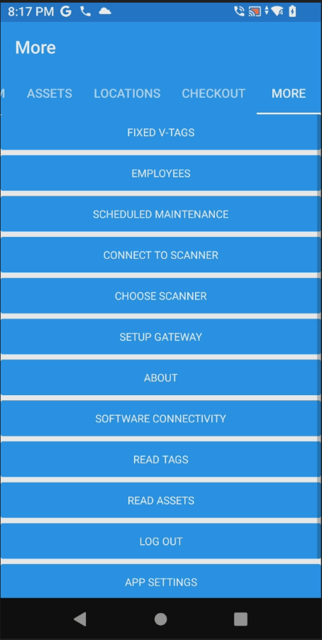
- Make sure “Zebra Sled” is showing. Click “SAVE”. You should hear a beep and the Zebra Sled will now be connected. You may begin scanning inventory.
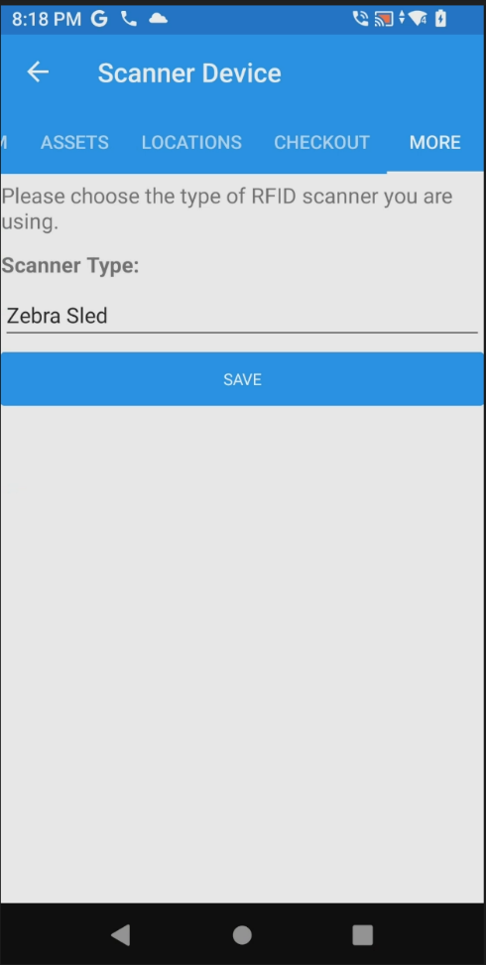

How to Install AssetWorx! to a Zebra Sled
* If AssetWorx! VA Mobile Application is installed on your reader, follow steps 1-3 then skip steps 14-17 below.
* If AssetWorx! VA Mobile Application is not installed on your reader, start on step 4 in this document. This process will be followed should you need to update the application in the future. Support is available and will walk you through this process if necessary.
- Open the AssetWorx! VA Mobile Application
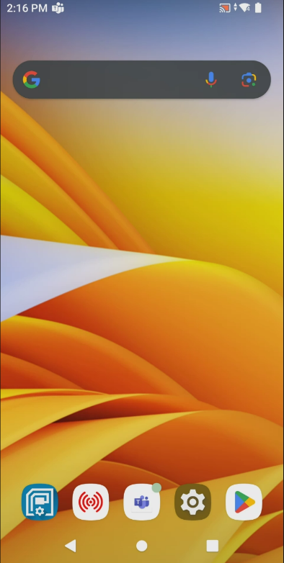
- Scroll over to “MORE” and click on “SOFTWARE CONNECTIVITY”
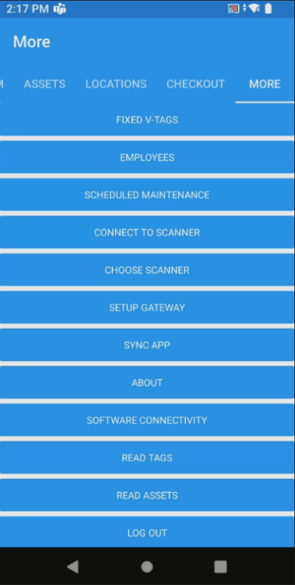
- Write down your “SERVER ADDRESS” to use on step 18
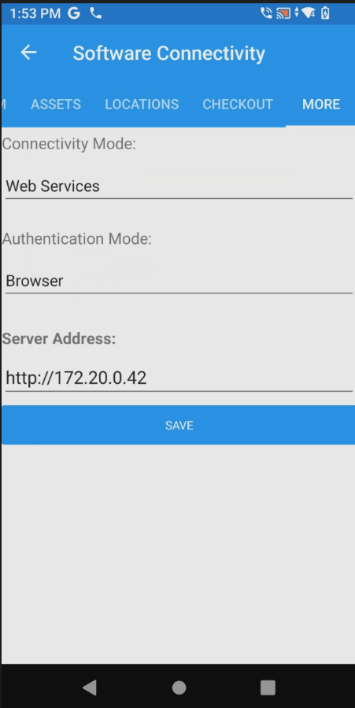
Be sure to copy the entire Server Address contents.
Next, continue to step 4.
- Activate TC53 reader by swiping up on the screen.
- Home screen will be like the image below:
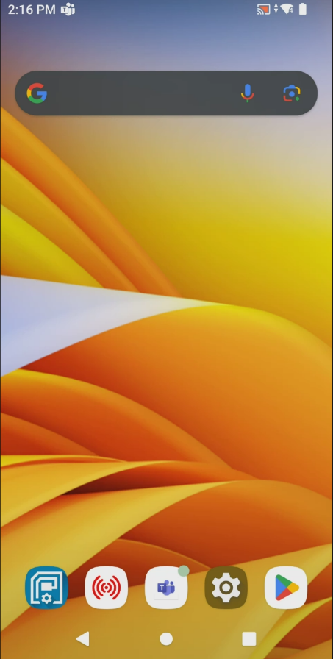
- Click on the “Play Store” icon.
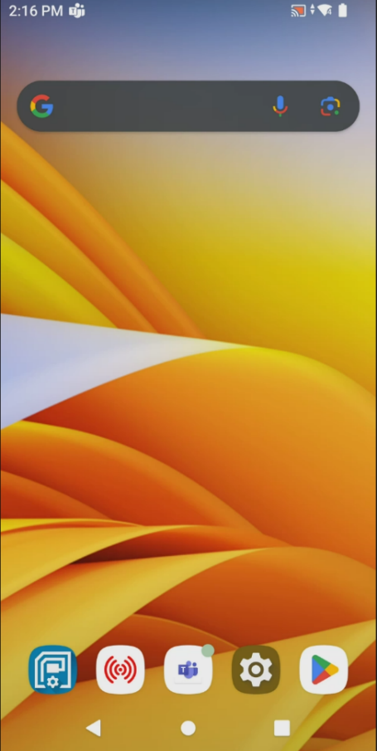
- Click on the search bar and type “assetworx va” to search for the application
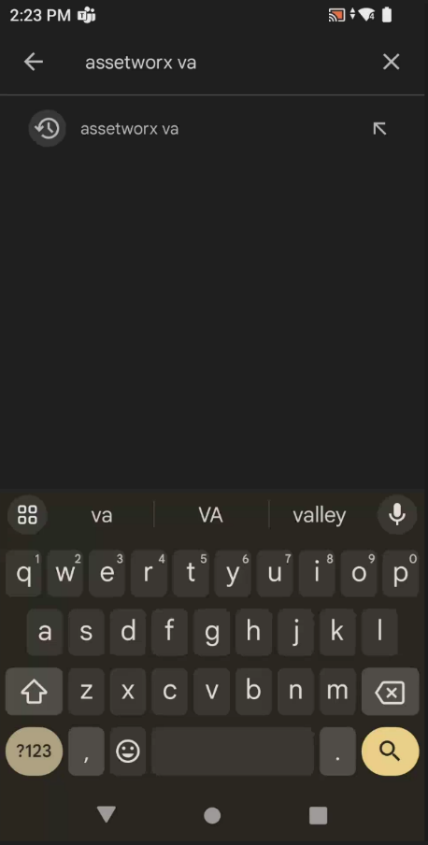
- Select the “AssetWorx VA” application icon when found.
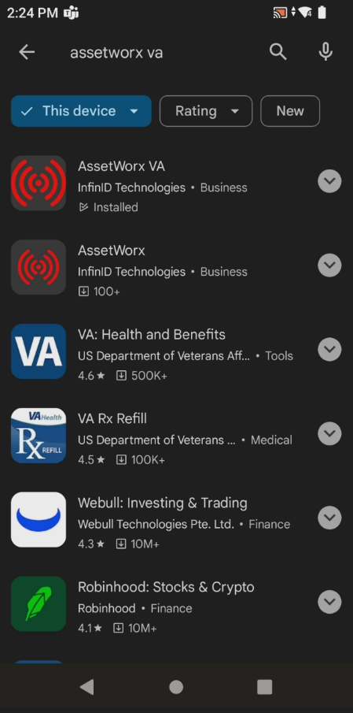
- Select “Uninstall”. *DO NOT select UPDATE
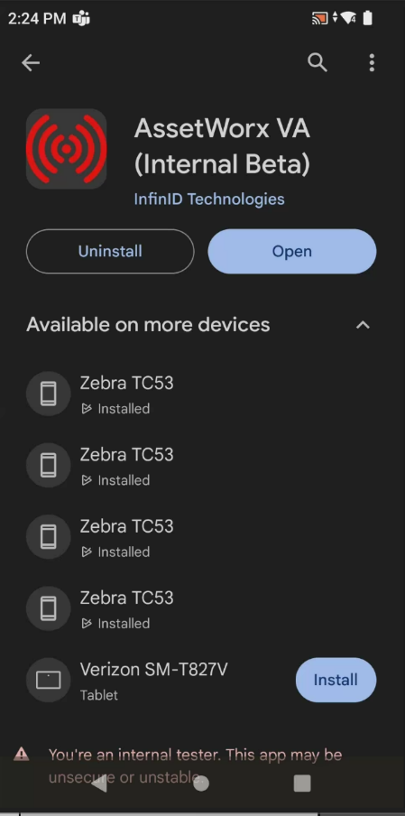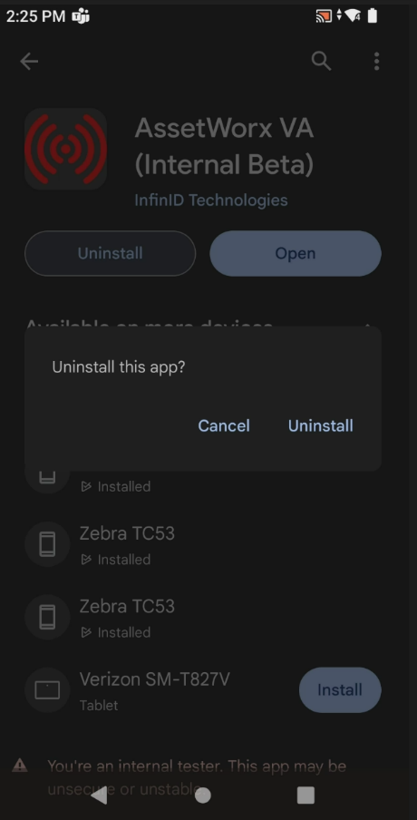
- Once the application has uninstalled, select “Install”.
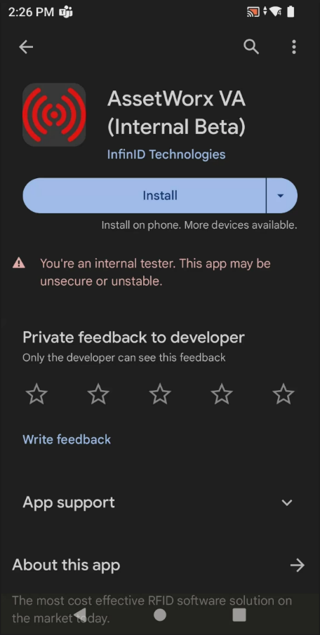
- Once AssetWorx! Mobile Application has installed, launch it by clicking “Open”.
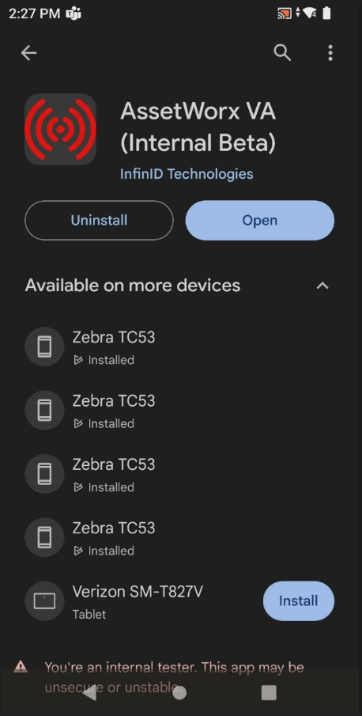
- Click “GET STARTED”.
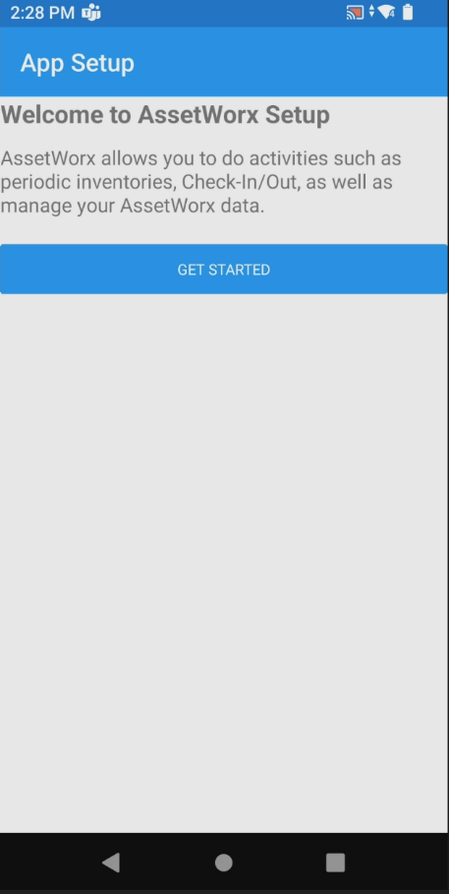
- Select by clicking “In App” under “Authentication Mode:” and select “Browser”.
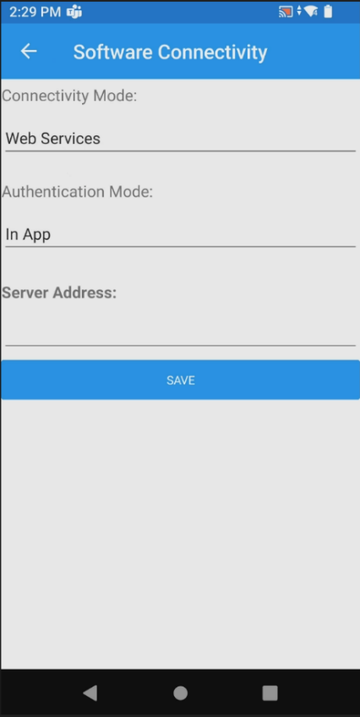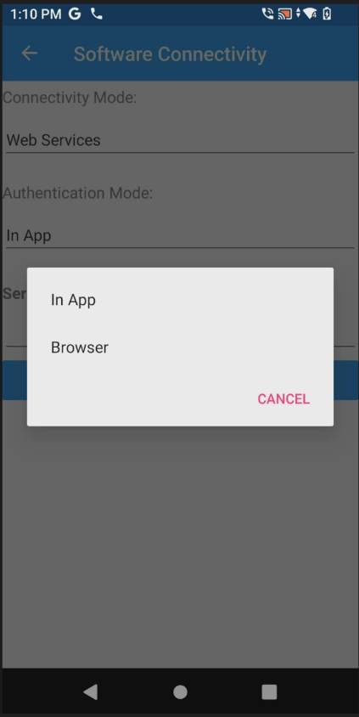
- If you need to find your “Server Address”, click on the start button (See picture below)
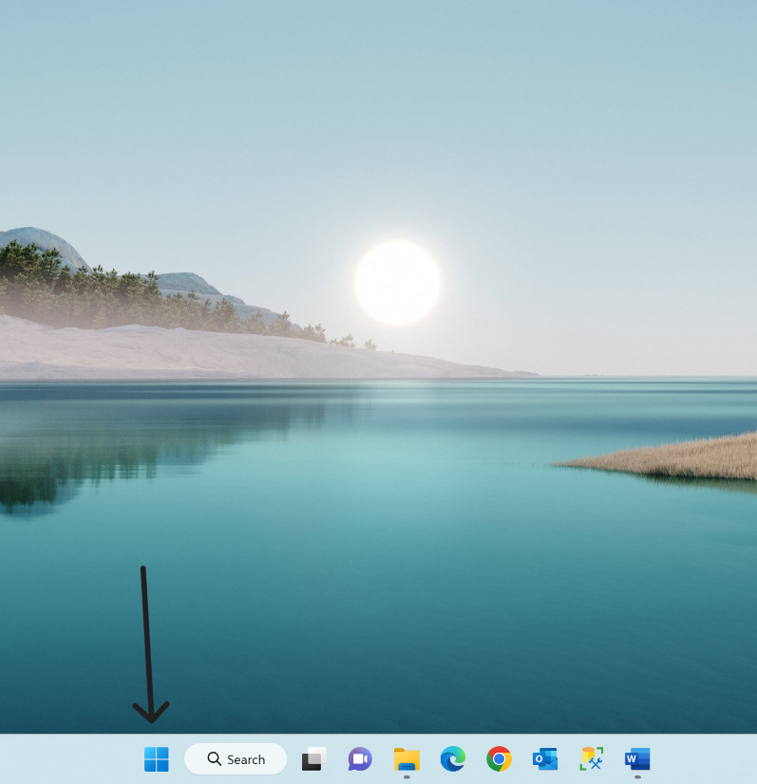
- Type “cmd” in the search bar and select the “Command Prompt” App
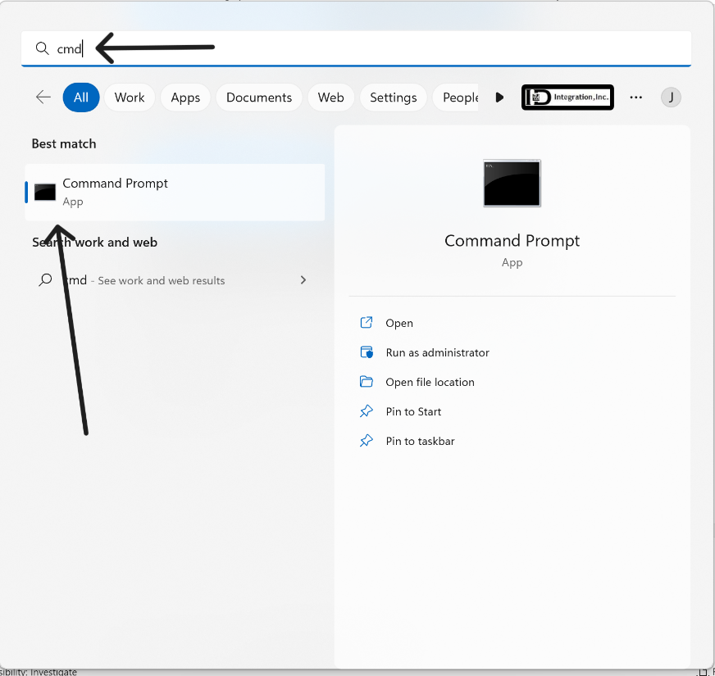
- At the “Command Prompt” window, type “ipconfig /all” and press “Enter” on your keyboard
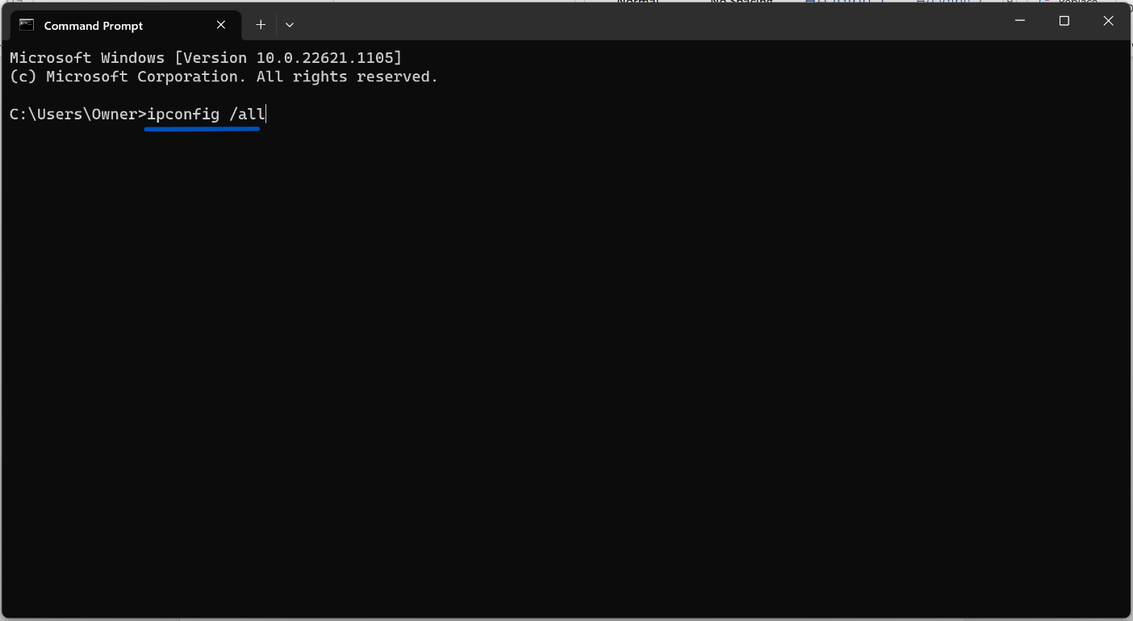

- Scroll down to “Wireless LAN adapter Wi-Fi:”
Note the IPv4 Address. You will need it for step 18 below.
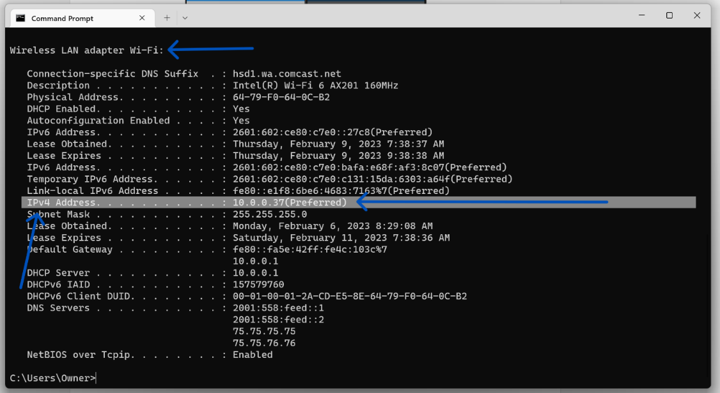

- Enter the IPv4 Address under “Server Address:”, starting your sequence with “http://” followed by the IPv4 Address. For example: http://172.20.0.42 as seen in the picture below
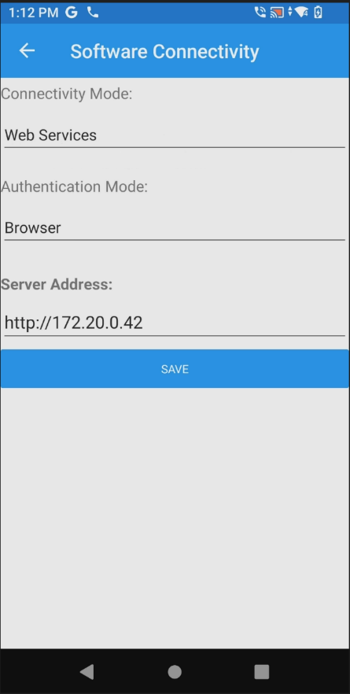
- Click “SAVE”
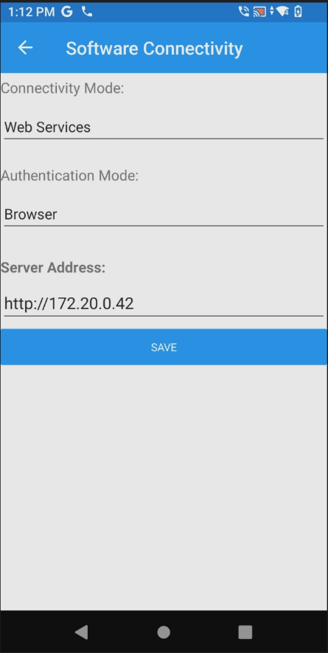
- Now select “Scanner Type:”, click under “Scanner Type:”, and select option “Zebra Sled”
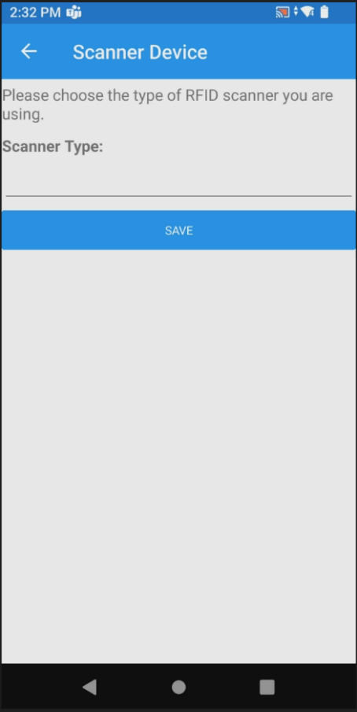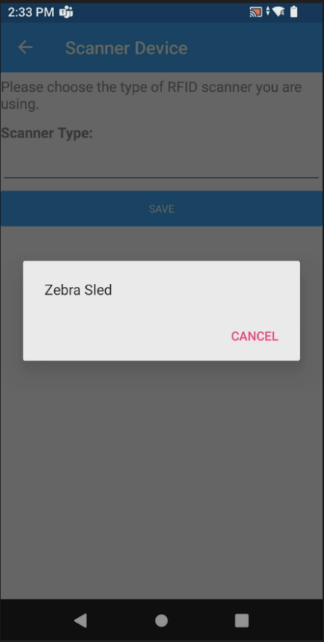
- Click “SAVE”
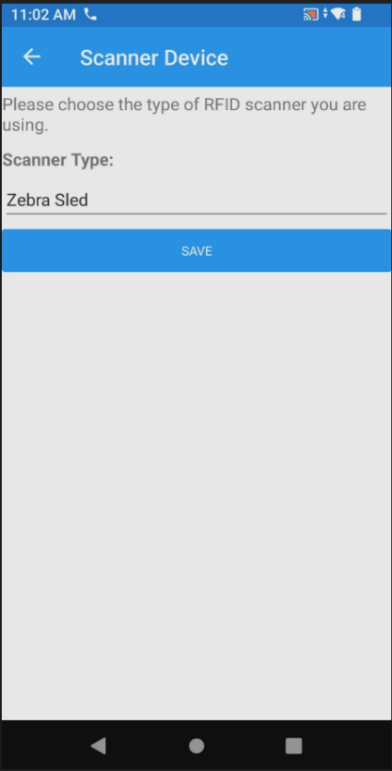
- When prompted to sign in, username and password are: (Username: Site #, Password: Site #). Type them in each box and click “Login.”
In this example, the Site # is 540, so the Username and Password are both 649.
Prescott will use 649a for admin user and password.

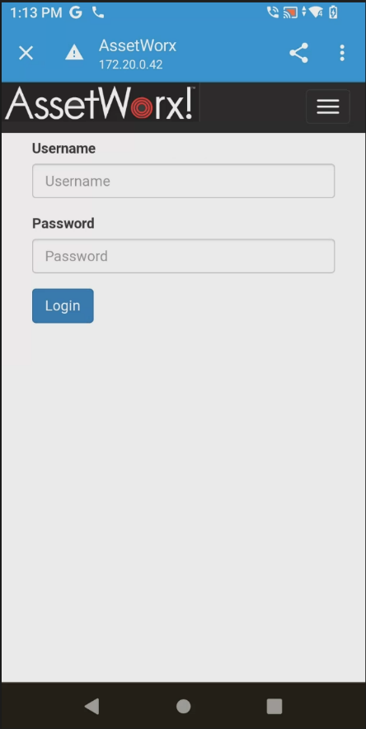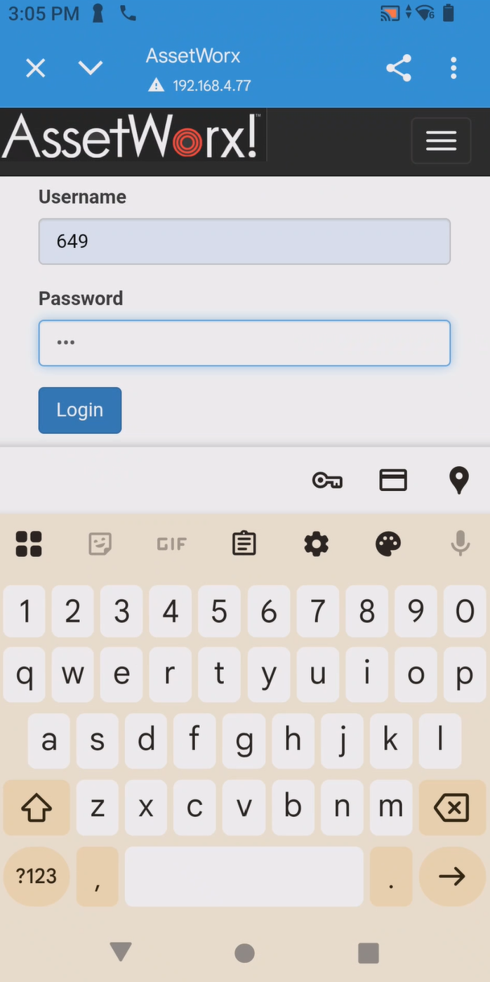
- When “Access Location?” pops up, click “YES”, then click “ALLOW”
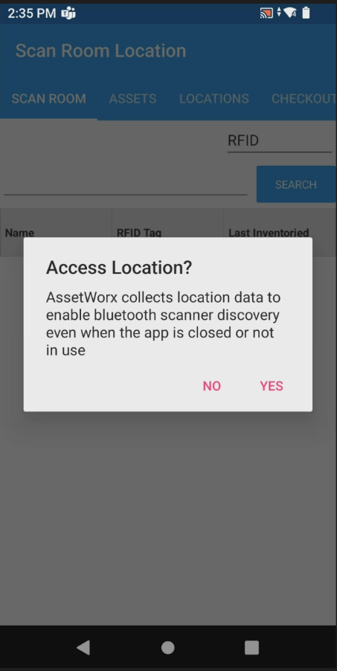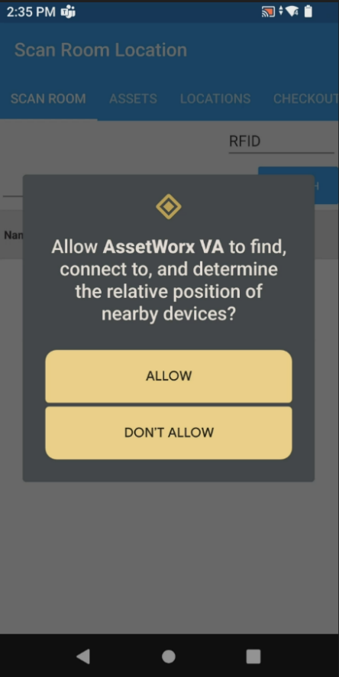
- The RFID reader is now ready to use. Scroll to “SCAN ROOM” and begin your inventory. Use the bottom trigger on the RFID reader to scan the linear location label, then use the top trigger on the RFID reader to RFID read the room. Alternatively, you may just continue to barcode scan.
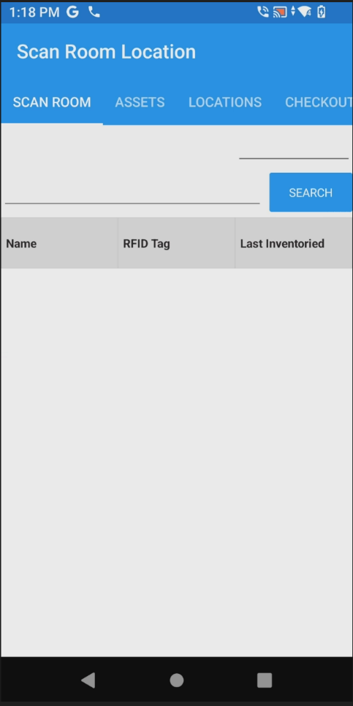

Using Web Services Mode on AssetWorx! VA Mobile Application
The intent of this document is to show users how to use AssetWorx! VA Mobile Application in Web Services mode. Web Services Mode takes away the need to “Sync App”.

Turn the reader on and swipe the screen to get started.
Close any open applications.

For AssetWorx! VA to work correctly, make sure the site laptop used to print, and the TC53 RFID reader are connected to your vendor provided MiFi wireless network. Also, make sure the Zebra Sled is connected via Bluetooth.

Follow these instructions to connect Wi-Fi and make sure you are ready to use AssetWorx!

Settings
Initial settings screen will be presented
Select Settings on Home Screen. Settings Screen
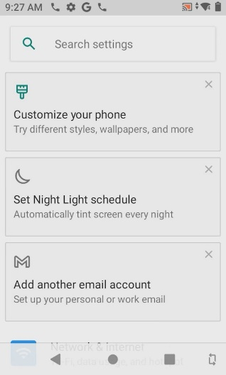
Settings menu will be used to configure many different items

Scroll and click “Network & Internet” Select “Wi-Fi”
Your MiFi device will have a name like “Franklin” or “Verizon”. Please call support if you have questions or problems locating it
Scroll up to see “Network and Internet” settings
Find and choose your network to connect. The Wi-Fi network used at the VA is called “Verizon”

Bluetooth
Select “Connected devices” Saved devices
If your device is already connected you can continue to the next page of this document. You will know it is your device if the last 4 digits match the S/N of your Zebra Sled. “0013” in this example.

If no device is connected
Click on, “Pair new device”
Once it is paired, you will see it under, “Saved devices”. Continue to the next page of this document.
Squeeze the trigger on the Zebra sled and wait for it to pop up under, “Available devices”, then click on “PAIR”.

Next, open the AssetWorx! VA Application
by clicking the icon on the home screen. You may be prompted to sign in
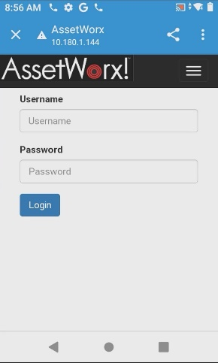
You will need to enter your username and password.
Username: 649
Password: 649

AssetWorx! VA application icon

Scroll to “SCAN ROOM”
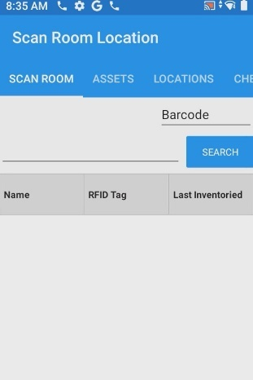
You can ignore this box. It may be blank, or say “Barcode” or “RFID”. To use Barcode on your Zebra Sled, pull the bottom trigger. To use RFID pull the top trigger. You will pull the bottom trigger to scan the linear location label inside the door jamb of the room you are scanning.
Scan Room is the default screen which will be blank until you scan a location label
Now scan the “Location Label” located in the door jamb by squeezing the bottom trigger of the reader.
You will see a red/green dot/line and will be able to scan the linear location tag.
After scanning the location label your reader will beep and populate with items expected in the location. Expected items will be Orange.

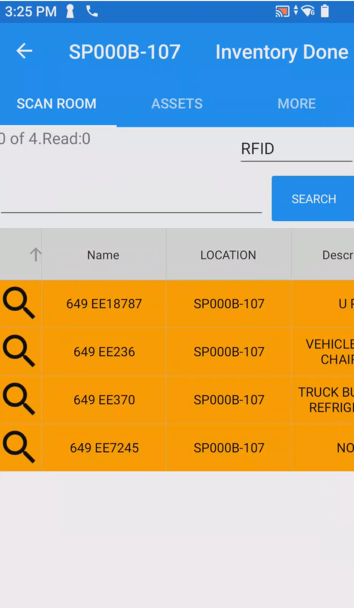
Orange colored items are what is expected to be in the location you are scanning.
After scanning the location tag you will always see a population of Orange assets.

Scan Room Assets by squeezing the top trigger of the Zebra Sled and moving the reader next to all the assets in the location. You will hear beeping when an asset label has been read by the reader.
*It is worth noting that you do not have to use the top trigger for RFID reading. If preferred, you may keep scanning using bottom trigger for Barcode mode. Just start scanning barcodes on the labels.

When scanning is complete you will see assets on the screen change status to Green, Orange, Blue, or Pink. Each color represents the following:
- Orange: Item is expected in location but not found or scanned yet. You may choose to keep looking or just ignore them.
- Green: Asset was expected after scanning location label and found when scanning.
- Blue: Item was found by scanning, but not expected in this location. You can choose to ignore or move this item to the current location by clicking on the item.
- Pink: Ignore these items. They are not your assets. They are likely RFID shipping labels, or other RFID items that are not your assets.
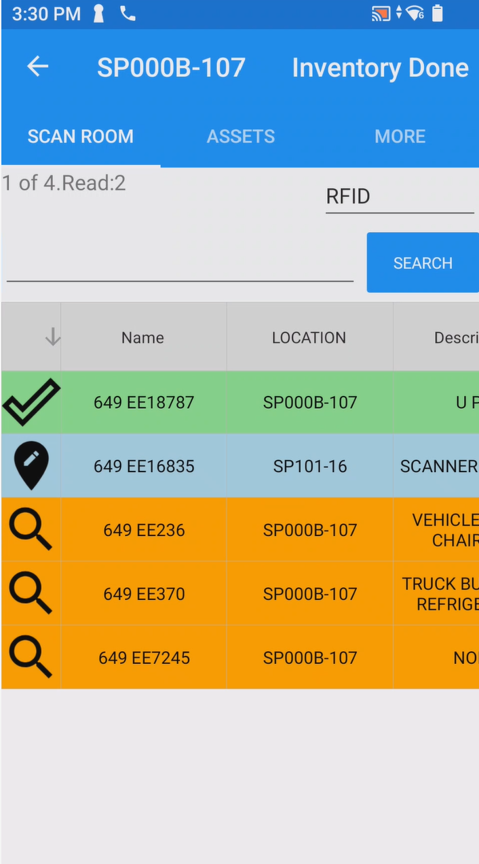
After scanning, you may also see assets turn Blue. Blue represents items that were found, but not expected in this location.
After scanning, you will see assets turn Green. Green represents expected and found items.
When you have Blue items, you may choose to either ignore, move one into the current scanned location, or there is an option to move all items that are blue, saving you time; see images and descriptions below.
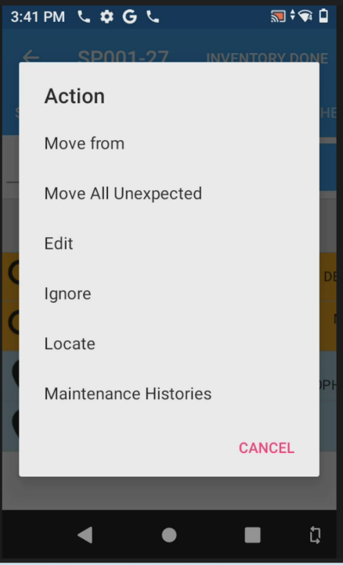
To move the Blue items into the current location you are scanning, click here on one of the Blue items.
You will be shown these options once you click on the Blue item. You may choose to move only that one asset by selecting “Move from” or you may move all Blue assets by selecting “Move All Unexpected”. Once you move the Blue item it will turn Green.

When you are done scanning this location, click “INVENTORY DONE”
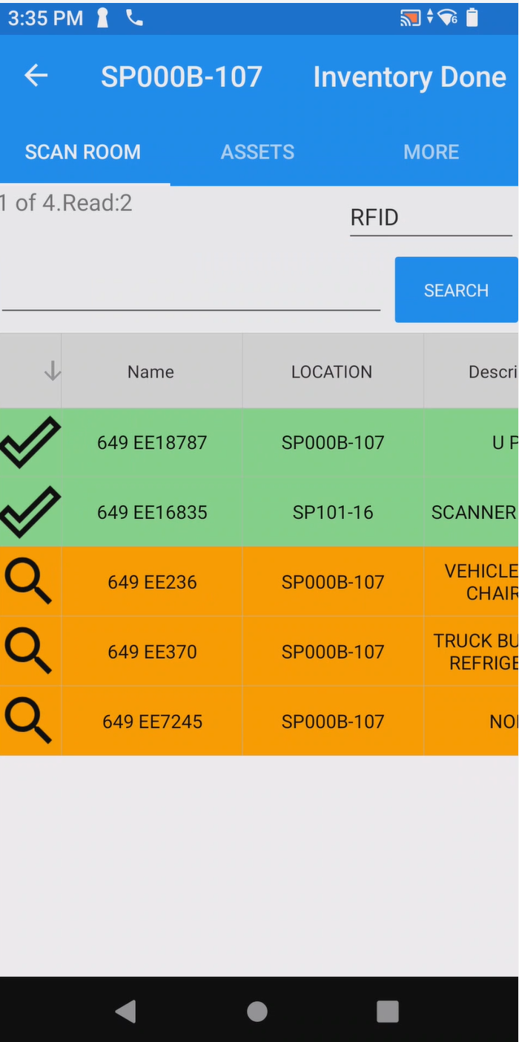
“INVENTORY DONE” is your SAVE button and is in the upper right corner of the application.
*Clicking INVENTORY DONE will save your scanned location and give you a fresh sheet on “SCAN ROOM” to continue to scan another location.

Proceed to scan another location if desired. To do so, repeat the steps above, starting with “Scan Room Home” and squeezing the bottom trigger of the Zebra Sled to scan the next location tag.

Once you are done inventorying all location, you are ready to create your ENNX report.

How to Use “Locate” Feature on Zebra Sled Reader
Locate Single Item
- Open the AssetWorx application on the Zebra Sled Reader. Click on “ASSETS”.
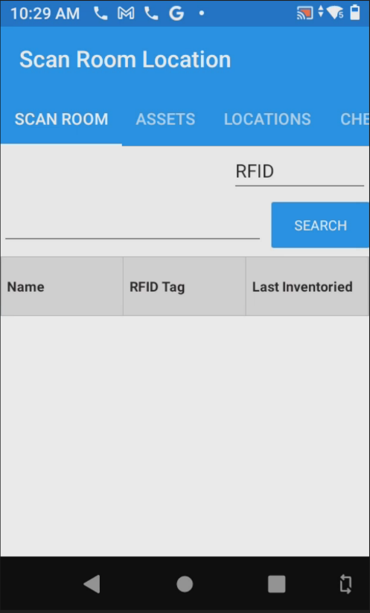
- Enter your EE # as shown, starting with your site number. See picture for reference.

- Click “Search” and the Asset will populate. Tap on it and select “Locate”.

- 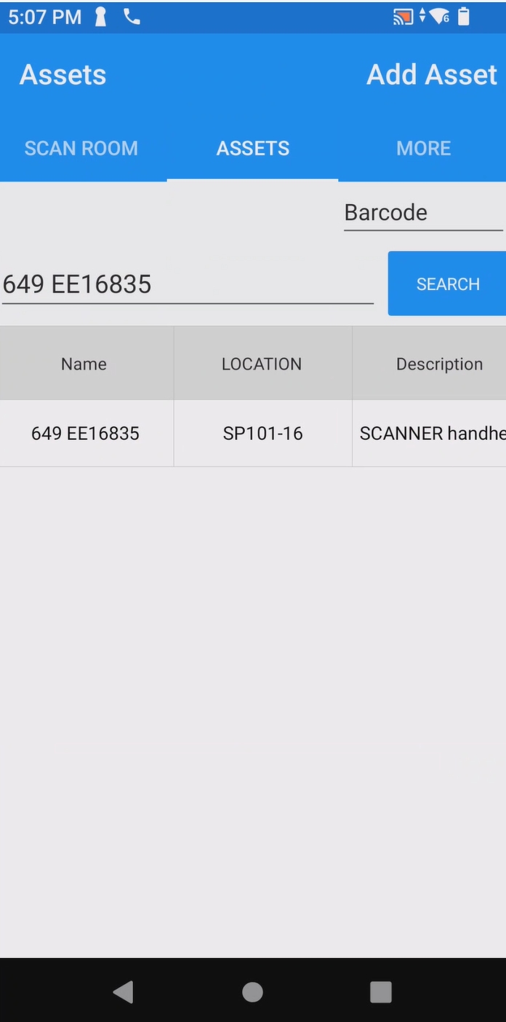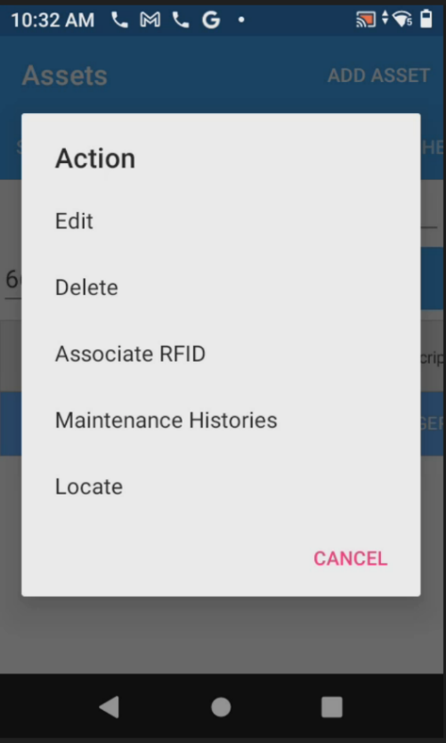

- Hold down the top trigger on Zebra Sled RFID reader. As you get closer to the item you are looking for the reader will start filling up a blue line below “Strength”. You will also hear a beeping sound. As you get closer the beeping will become higher pitched.
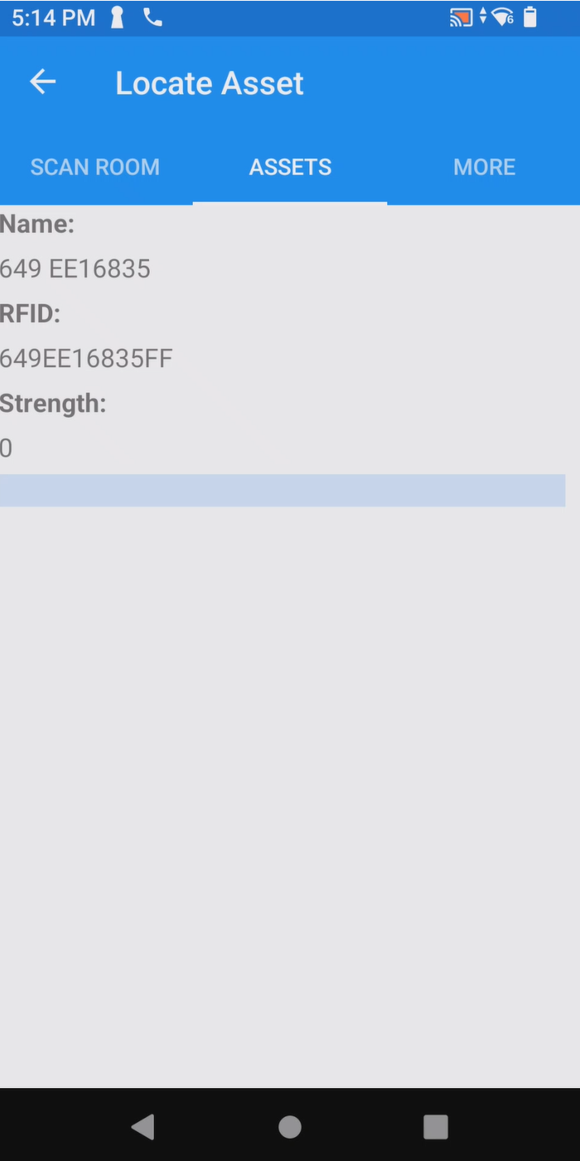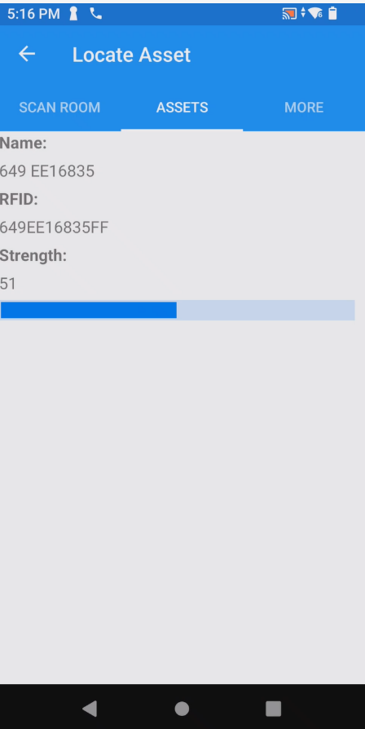
Locate a Single Item after Scanning Location
Another way to locate an item is by tapping it during an inventory of a room. In situations where you find items that you do not expect to find and display in Blue, follow these steps to locate those items.
- Squeeze the bottom trigger of the RFID reader and scan the linear location tag.
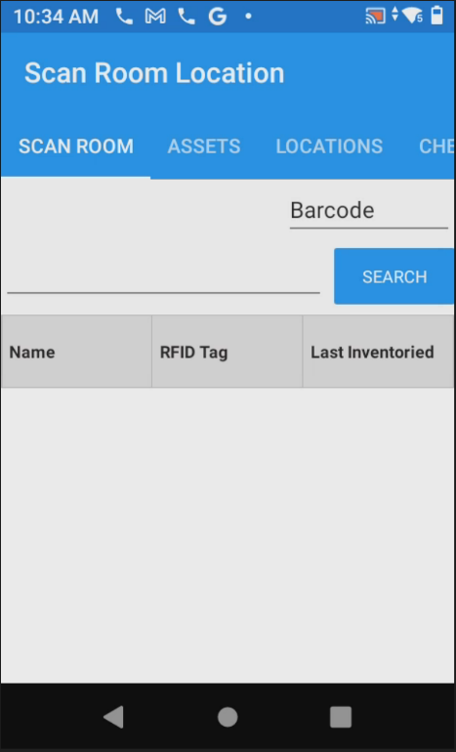
- Squeeze the top trigger of the reader and perform an inventory of the room. When complete, tap the box near “Name” as shown in the picture to re-organize the assets you scanned.
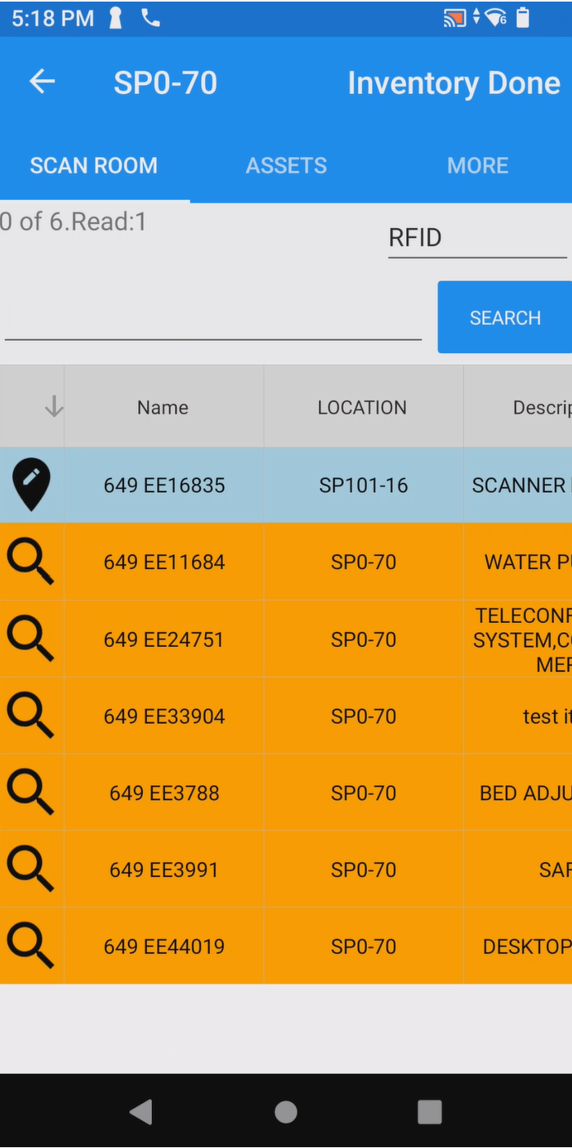
Re-organize your assets by tapping here. This will show the Green, expected, and Blue, not expected, items that you scanned. You can now locate items you have discovered in your location.
- After reading and scanning your location, click on the item you would like to locate and tap “Locate”.
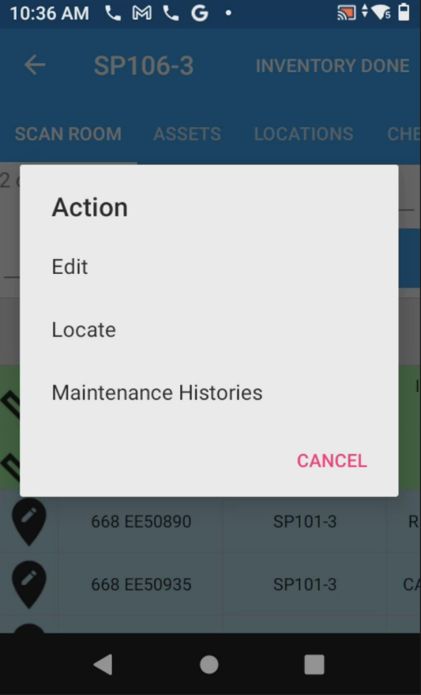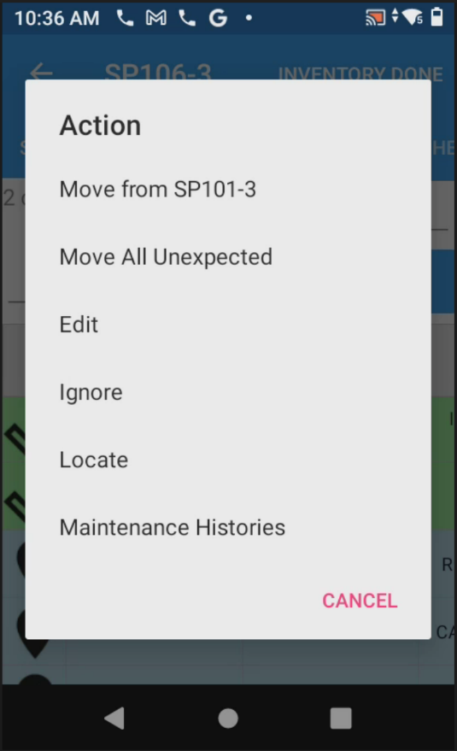
When you tap on an asset that is Blue, it will look like this. Tap “Locate”
Example of selecting a “Green” expected item found. Choose “Locate”

- Now squeeze the top trigger of the RFID reader. You will have a blue bar that fills up as you get
Closer to the item. You will also hear beeping and the sound will become higher pitched.
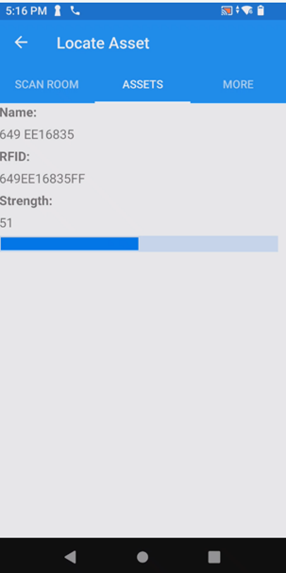

How to Adjust Power on Zebra Sled Reader
- Open the AssetWorx app. This is the main screen.
- 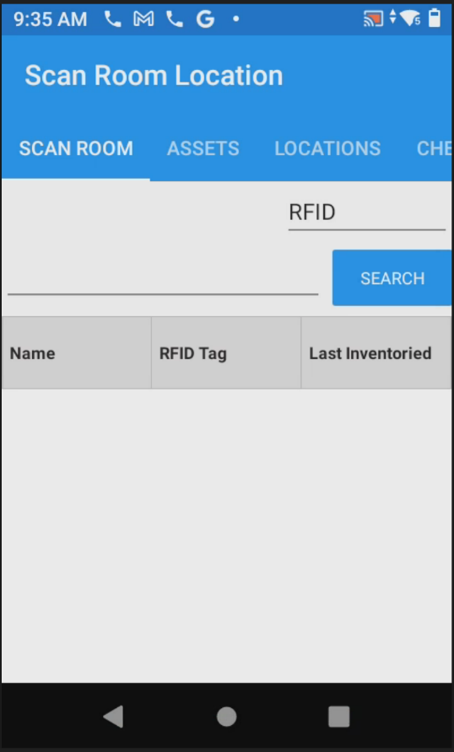
- Scroll over to “MORE”.
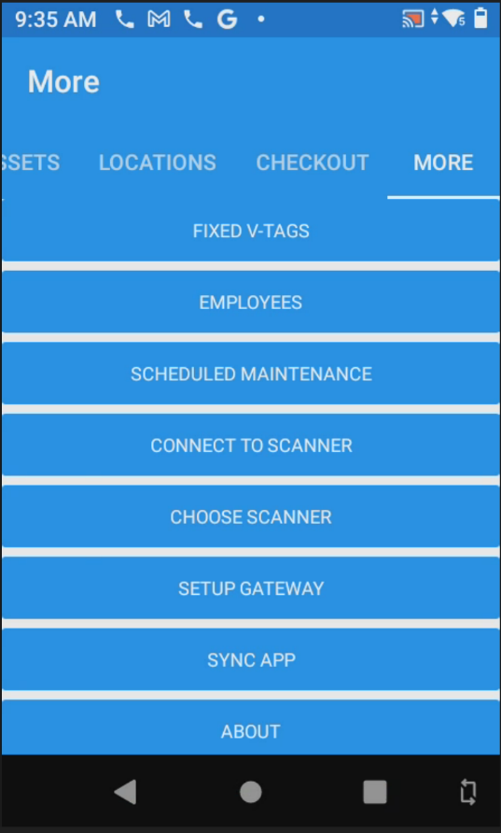
- Scroll down until you see the option “APP SETTINGS” and click on it.
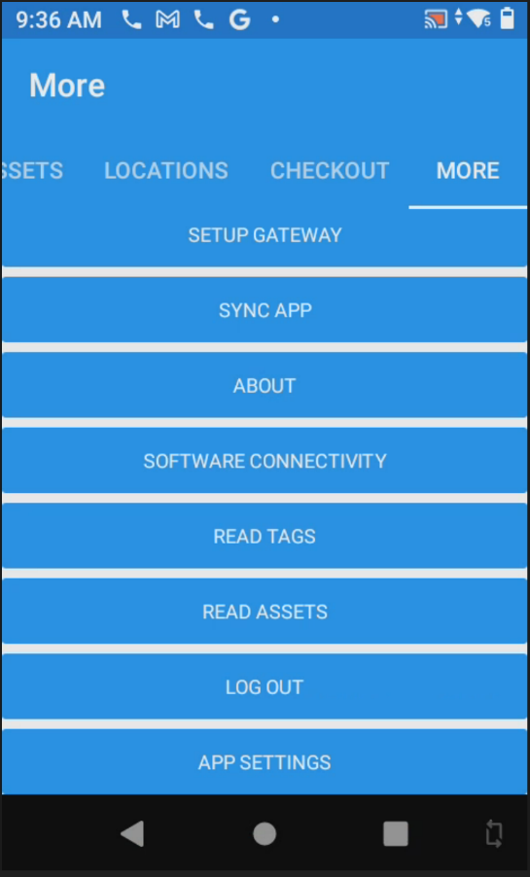
- Click on the number below, “Inventory Power Level (1-100):”, this will allow you to adjust the RFID power level on your RFID reader.
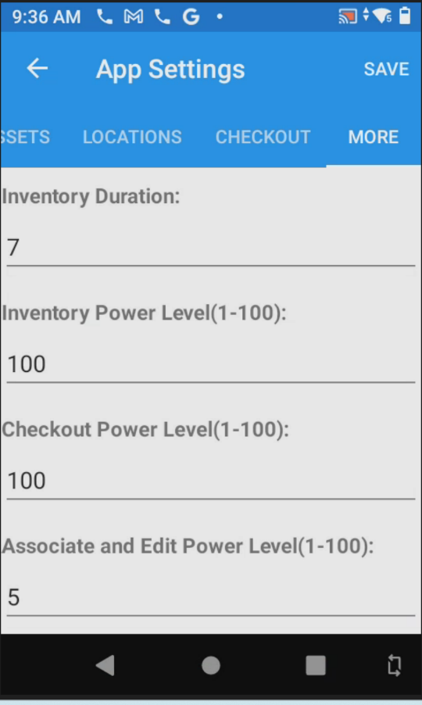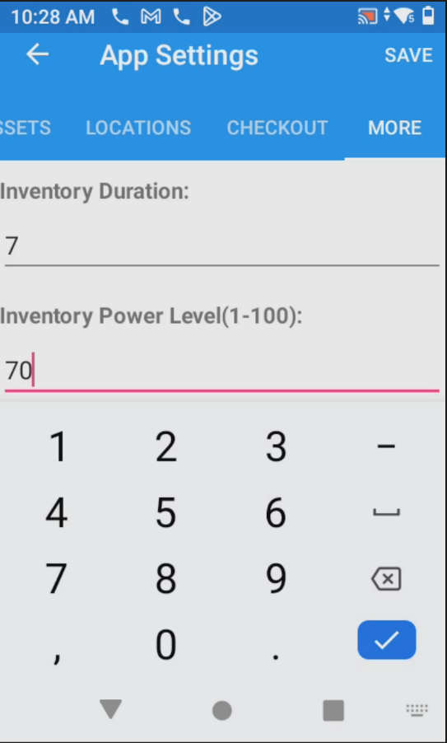
Once you click here, it will bring up a number pad and allow you to put in your desired RFID Power. 70 is recommended for areas where different locations are in close proximity to each other.
- Click “SAVE”. It will say “Settings updated”. You may continue to use the reader now.
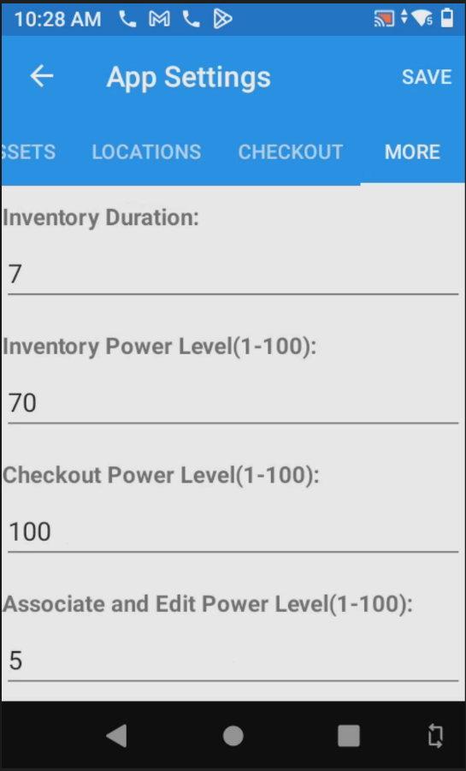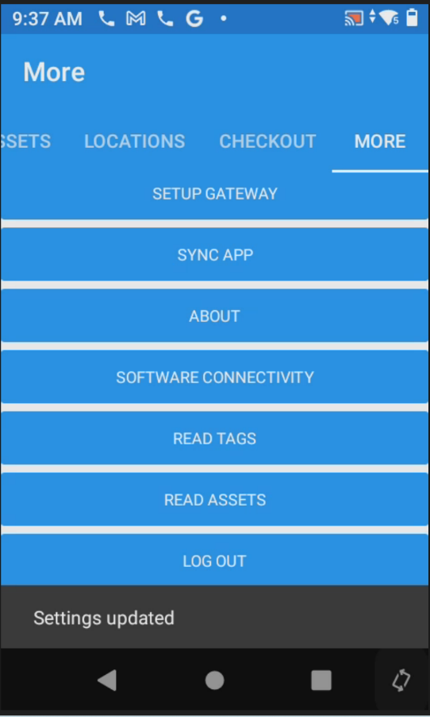

Missing Location Tag: What do I do now?
This document will help if the rooms linear barcode location tag is missing.
Our assumption here is that you have already signed in with your site # and you are now performing inventory or locating/relocating assets.
- Begin by opening AssetWorx! VA Mobile Application on the RFID Reader and scroll to “Scan Room”.

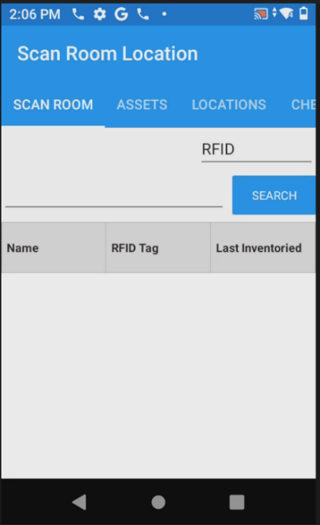
- Click to the left of the search bar to see the keyboard and type in the full location of the room.
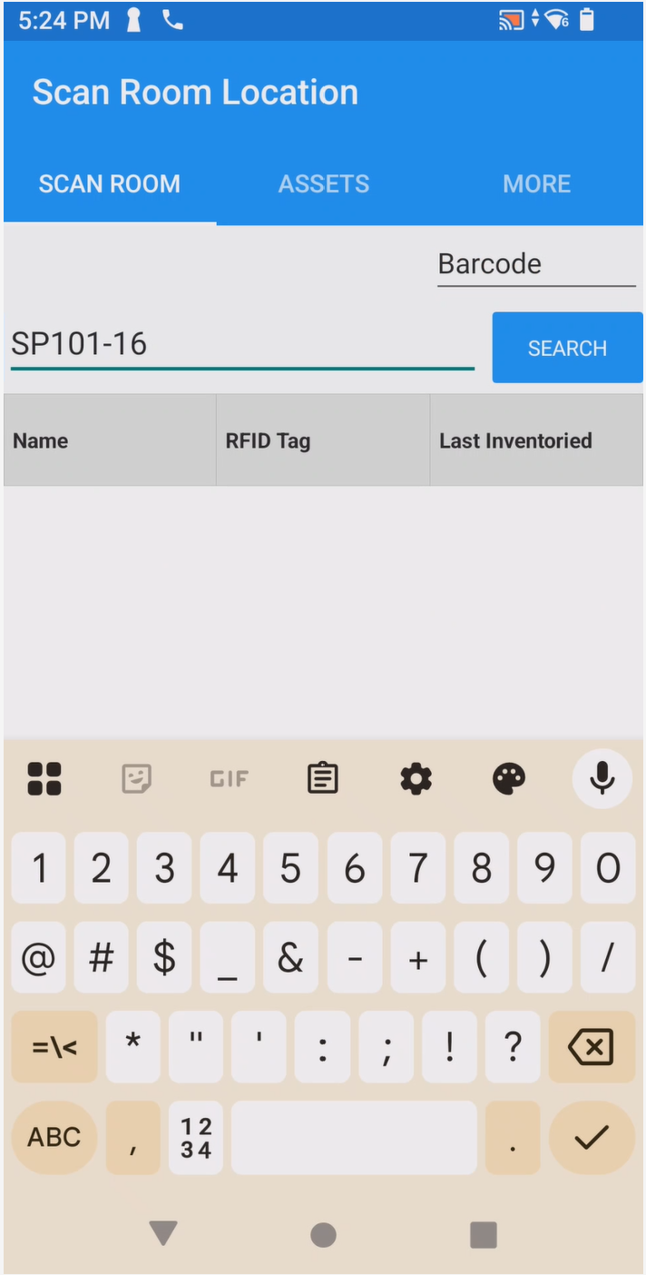
Tap here and type the location number. Then press “SEARCH”

- Location will populate as pictured below.
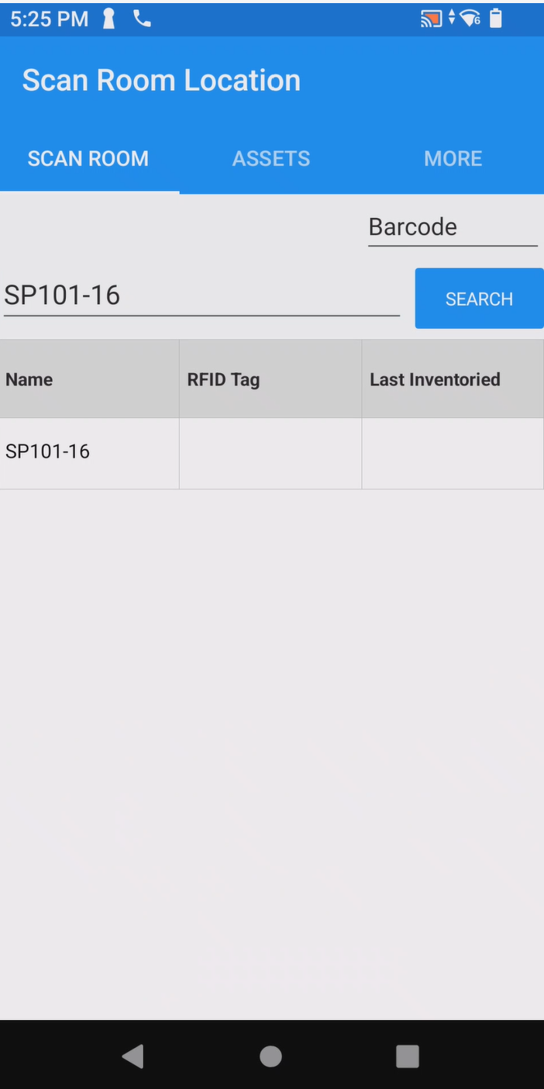
Location will populate as in this example after selecting “SEARCH”. Proceed by clicking (touching) the location.
- Items expected in this location will now populate as if you scanned the location barcode.
Application is now ready to proceed with inventory.
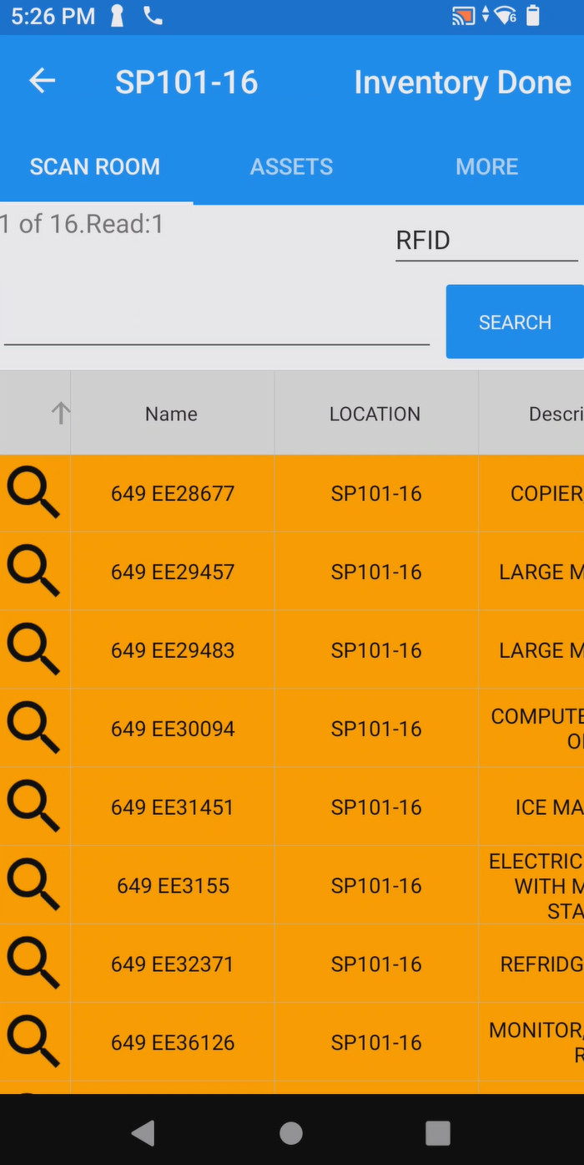
Squeeze the top trigger of the RFID Sled and proceed to scan the room.
You may also barcode scan items and alternate between methods depending on your preference.
When scanning is complete, select “INVENTORY DONE”. Proceed to perform inventory at other locations as needed.
****If there is another room that does not have a linear location tag, repeat the instructions above.

AssetWorx! VA Mobile Application Pink Asset Help: How to add to your location
*This document provides help if you have an asset that comes up as Pink when RFID scanning
Pink assets with showing EE# means that they are not in the database loaded to your Zebra Sled AssetWorx! Mobile Application. This document will help you add the asset to your inventory report.
- Identify that you have an item that came up as Pink.
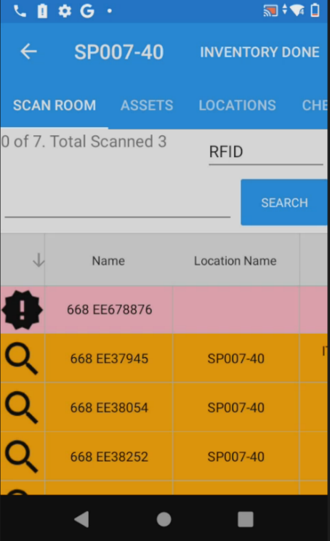
The item will look like this. Click on it.
- From the pop-up menu select “Add”.
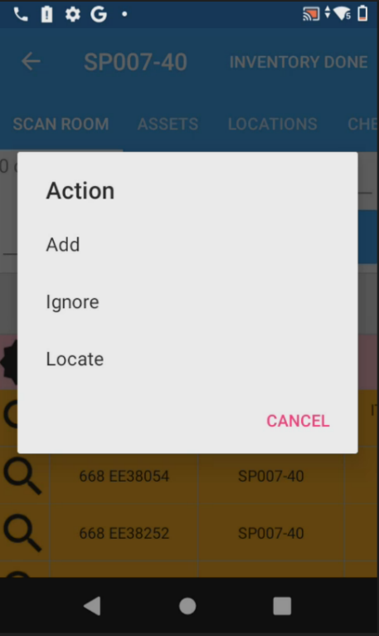

- This takes you to a page with the EE number already populated under “Name”.
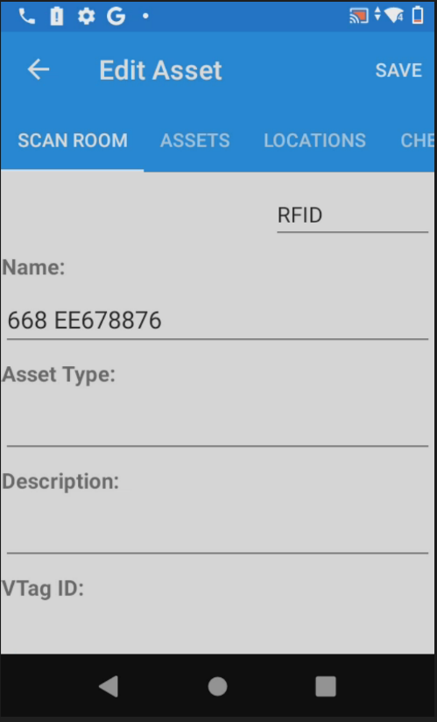
- Scroll down and fill in the following areas. Starting with Description.
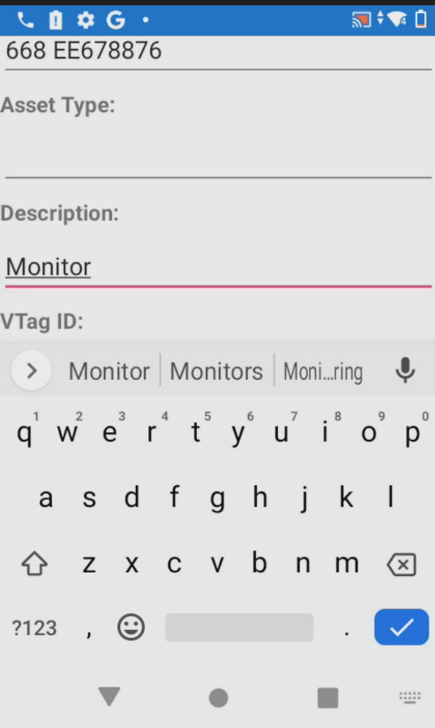
Click on the line below “Description:” When the keypad is presented, you will have the ability to type a description of the item.

- Scroll down and select “Location”.
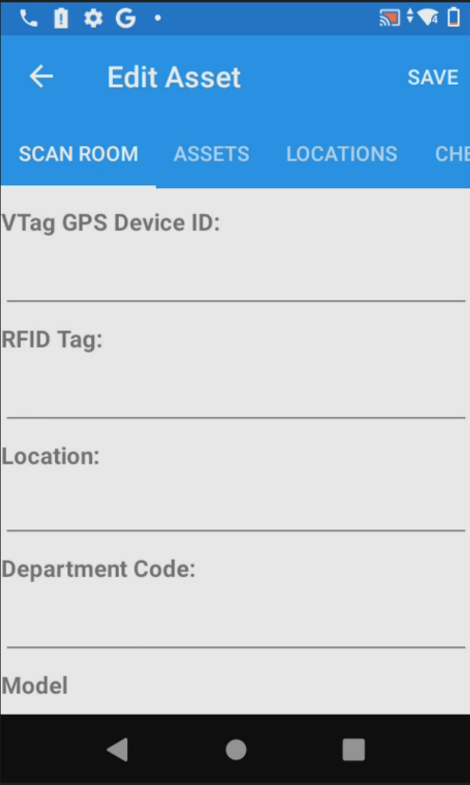
- Find the location you are adding the asset to and select it.
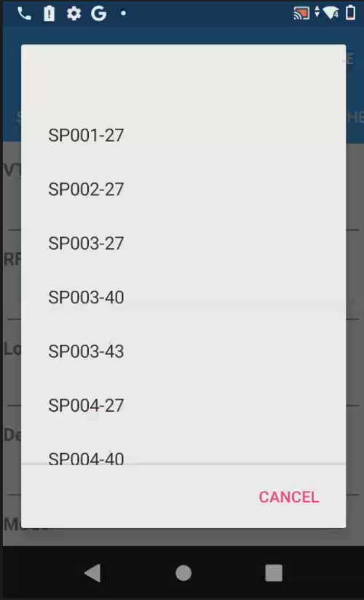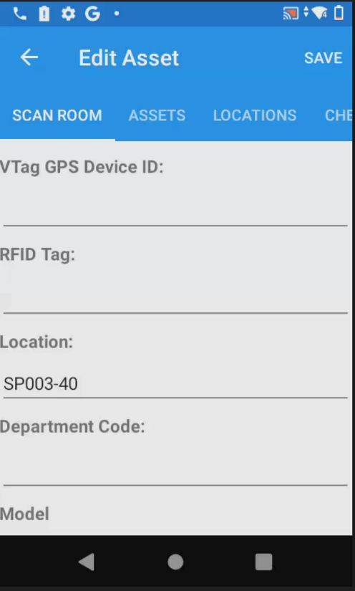
Find the location you are looking for by scrolling through the list.

- Populate the fields “Model” and “Serial Number” and select “SAVE”.
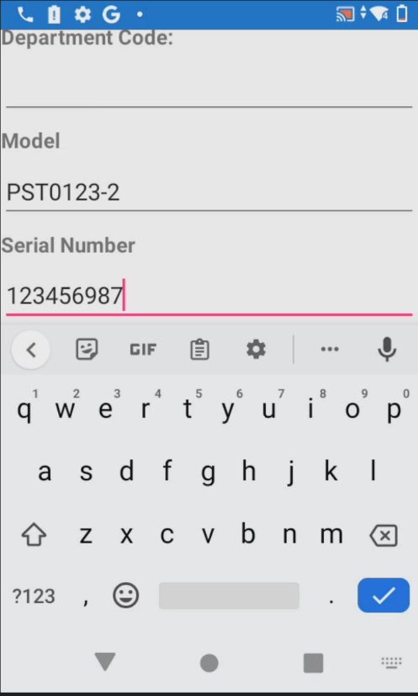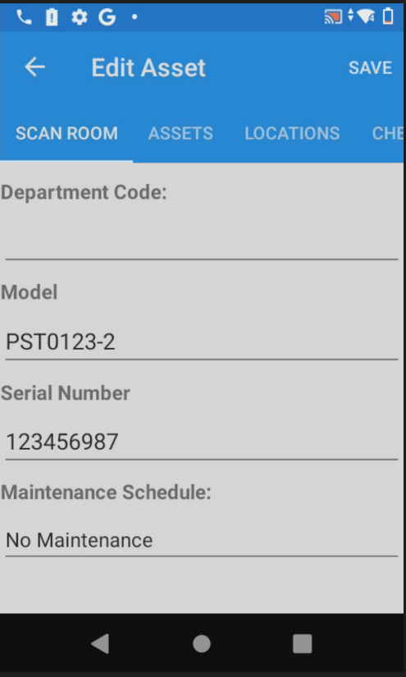
- The asset will now change to Blue or Green. If Green, it is accounted for in the location you are in. If Blue, click on the asset and select “Move from…” this will turn it Green, indicating it is now accounted for in this location.
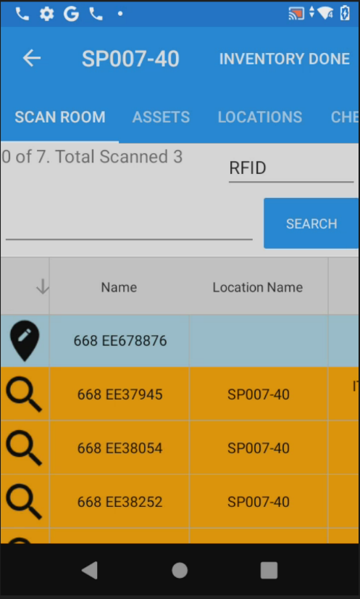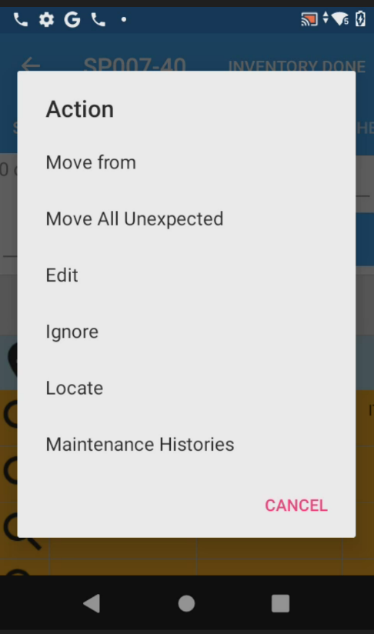

- When your item is Green, it has been added to the location and now will be moved or noted in the current location. Now select “INVENTORY DONE” and the asset will show in your report when inventory or location move is complete, and you create your ENNX report.
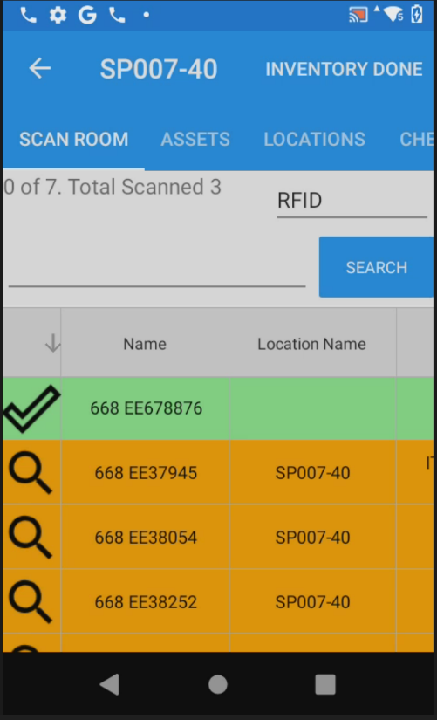

How to Use the Logout Feature on Zebra Sled Reader
*Using the logout feature will allow you to logout of AssetWorx and change users if necessary. Note that you will login again before using the reader for inventory.
- Open the AssetWorx app on the Zebra Sled Reader. This is the main screen.
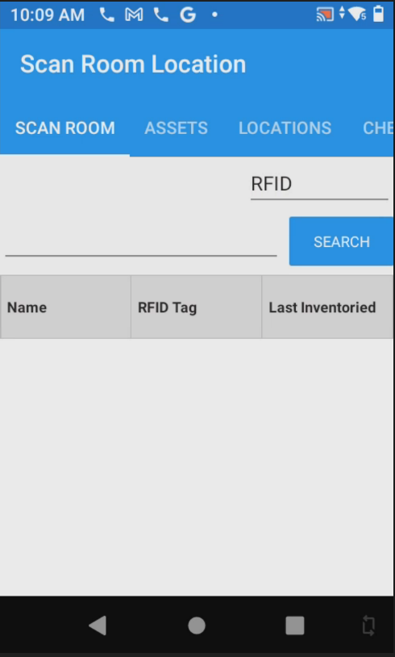

- Scroll over to “MORE”. Scroll down until you see “LOG OUT” and tap to select it.
- 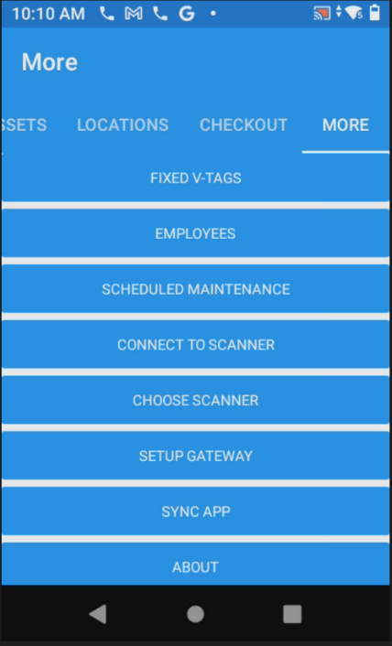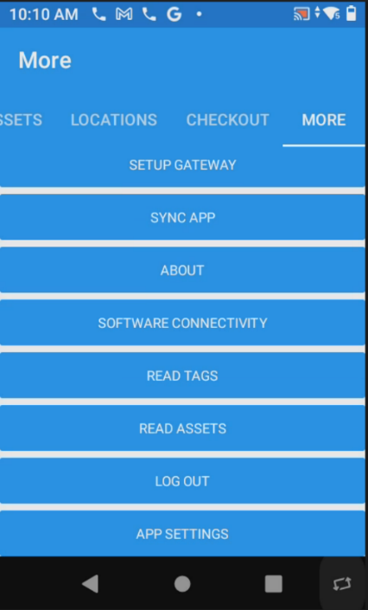

- You will be shown a screen that says “AssetWorx Initializing” wait a few seconds.
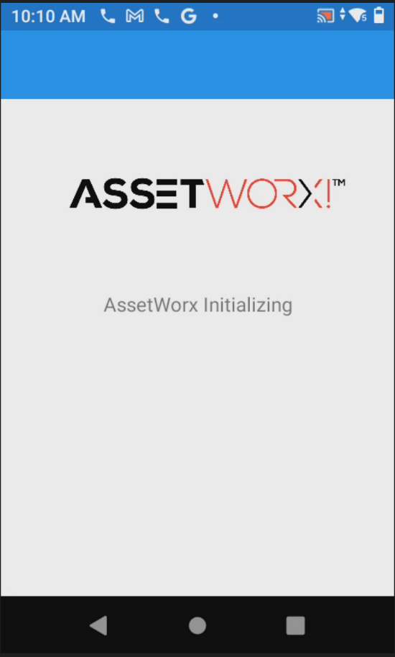
- You will be redirected to the login page of AssetWorx!. Login with Username: “Site #” and Password: “Site #”. In this example the Site # is “649a”.
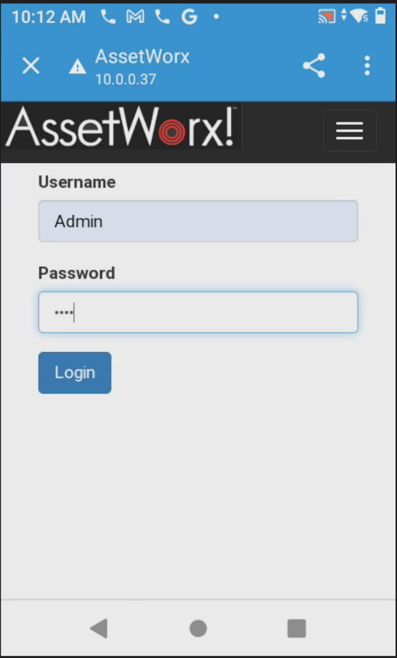

649a
- Once you click login, you will be directed to this page. You will notice it says, “Scanner already connected”, you may now continue to inventory.
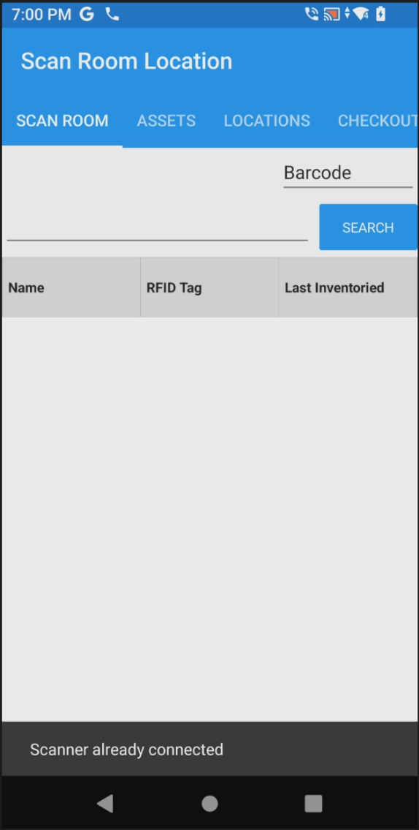

How to Get ENNX Report to Update Assets in AEMS/MERS
- Open Google Chrome web browser on the laptop. Then select “ID ENNX Report” in the upper left-hand corner.
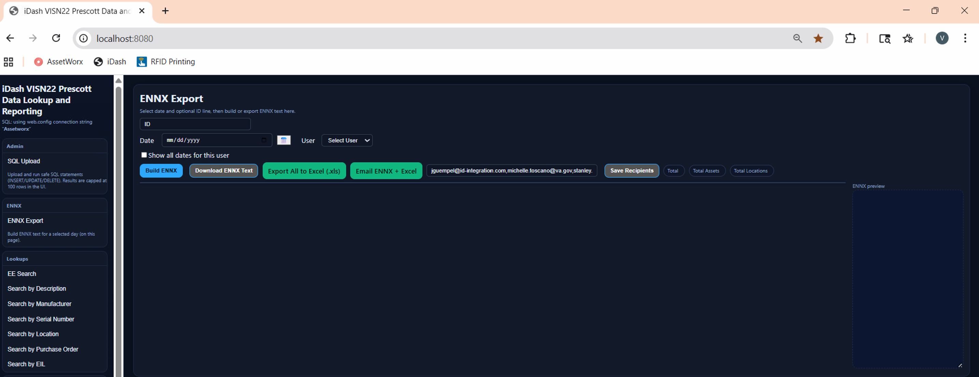
- Choose the date/day by clicking the calendar or typing it in
- Select your username from the drop-down menu
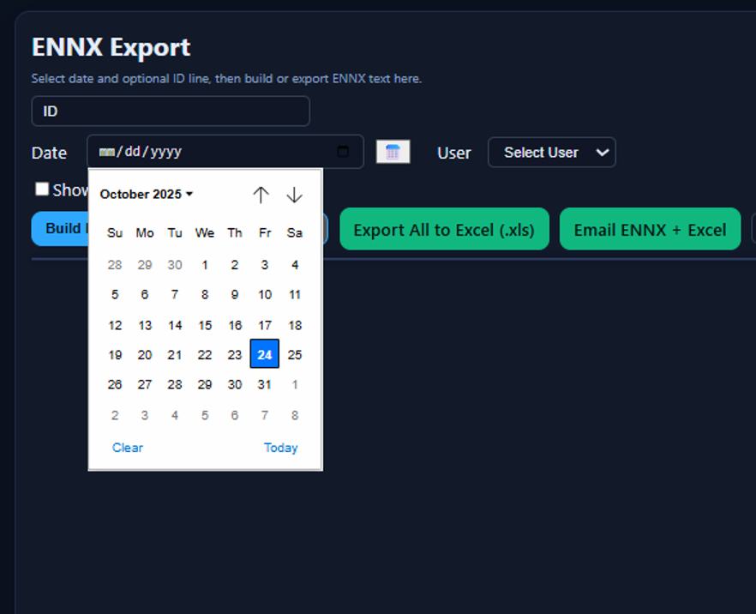
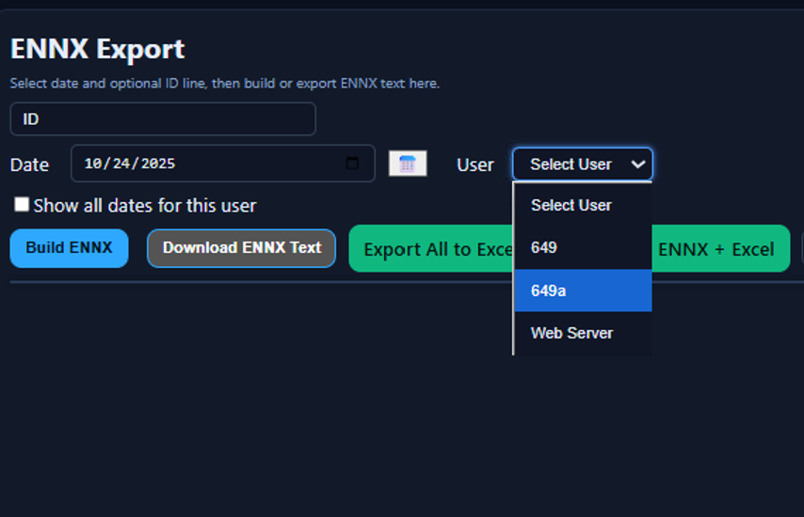

Select “Build ENNX”
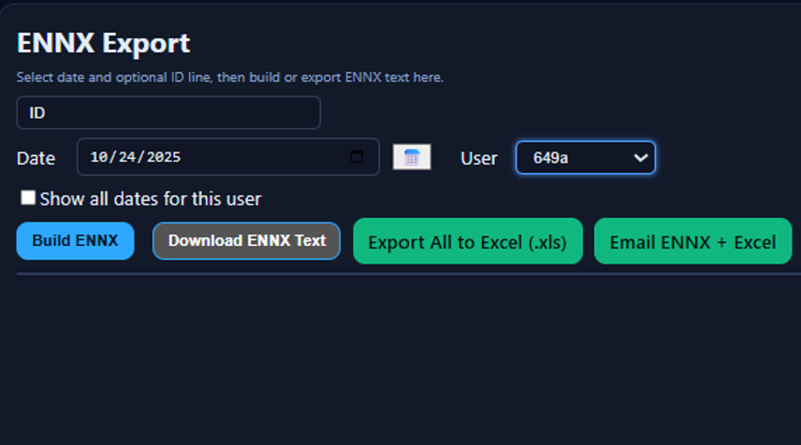

Your window will populate with your locations and scans like below
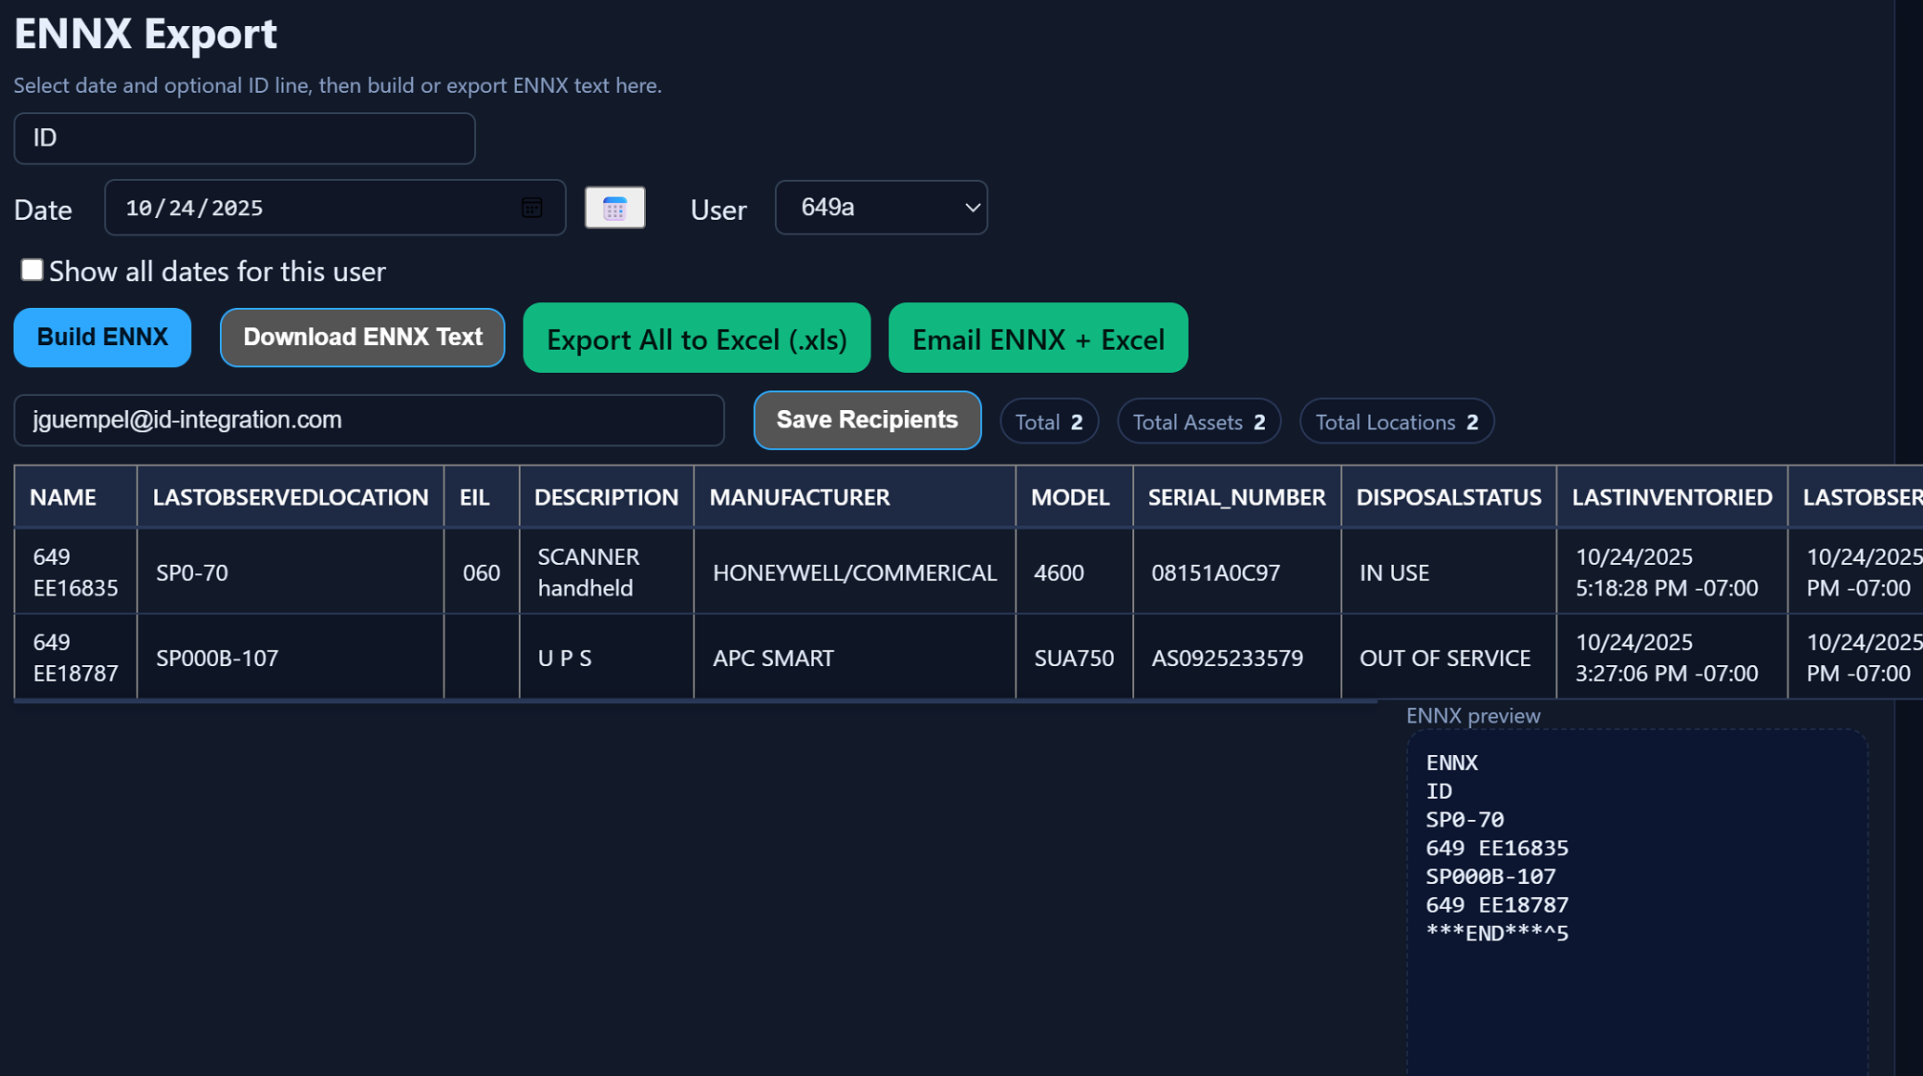

** Note that your recipient list will be different.
To download a text file of your ENNX file select “Download ENNX Text”
You may export the file to Excel by selecting “Export all to Excel”
Most times you will want to select “Email ENNX + Excel” to receive in your inbox and upload results to AEMS/MERS Vista.

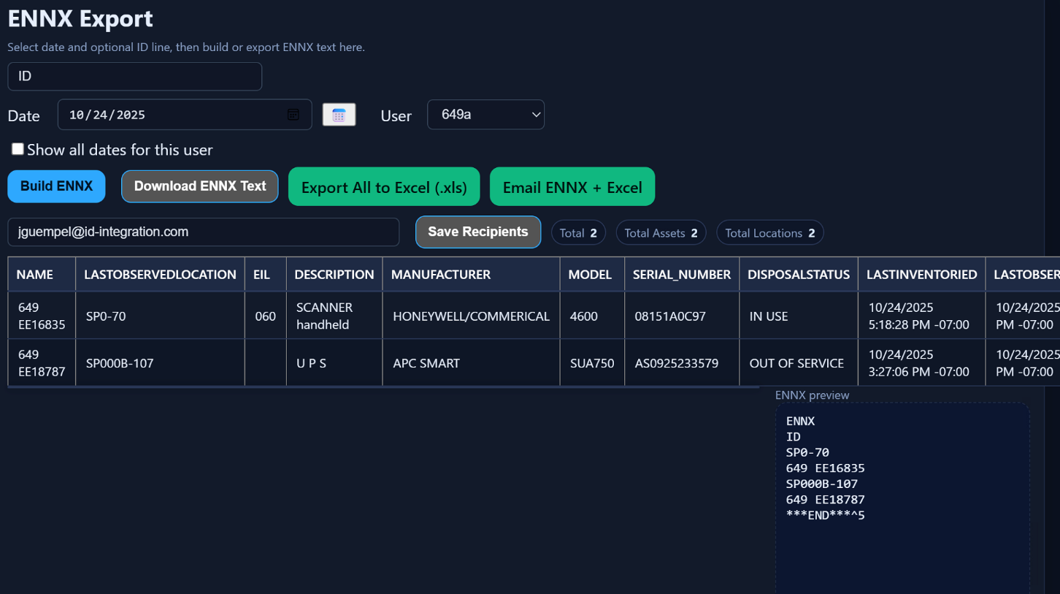

You will see a notification on the top left that looks like the picture below confirming the email has been sent.
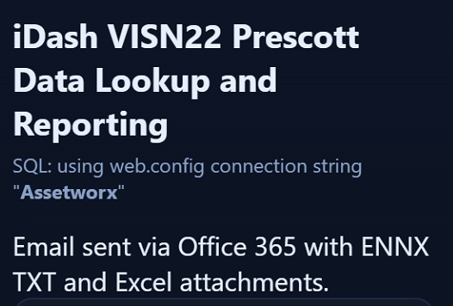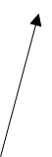

Check your inbox for your files emailed from V2269@id-integration.com

Open the email and find the attachments. Save them to your computer and upload to AEMS/MERS using the Barcode Uploader section as normal.

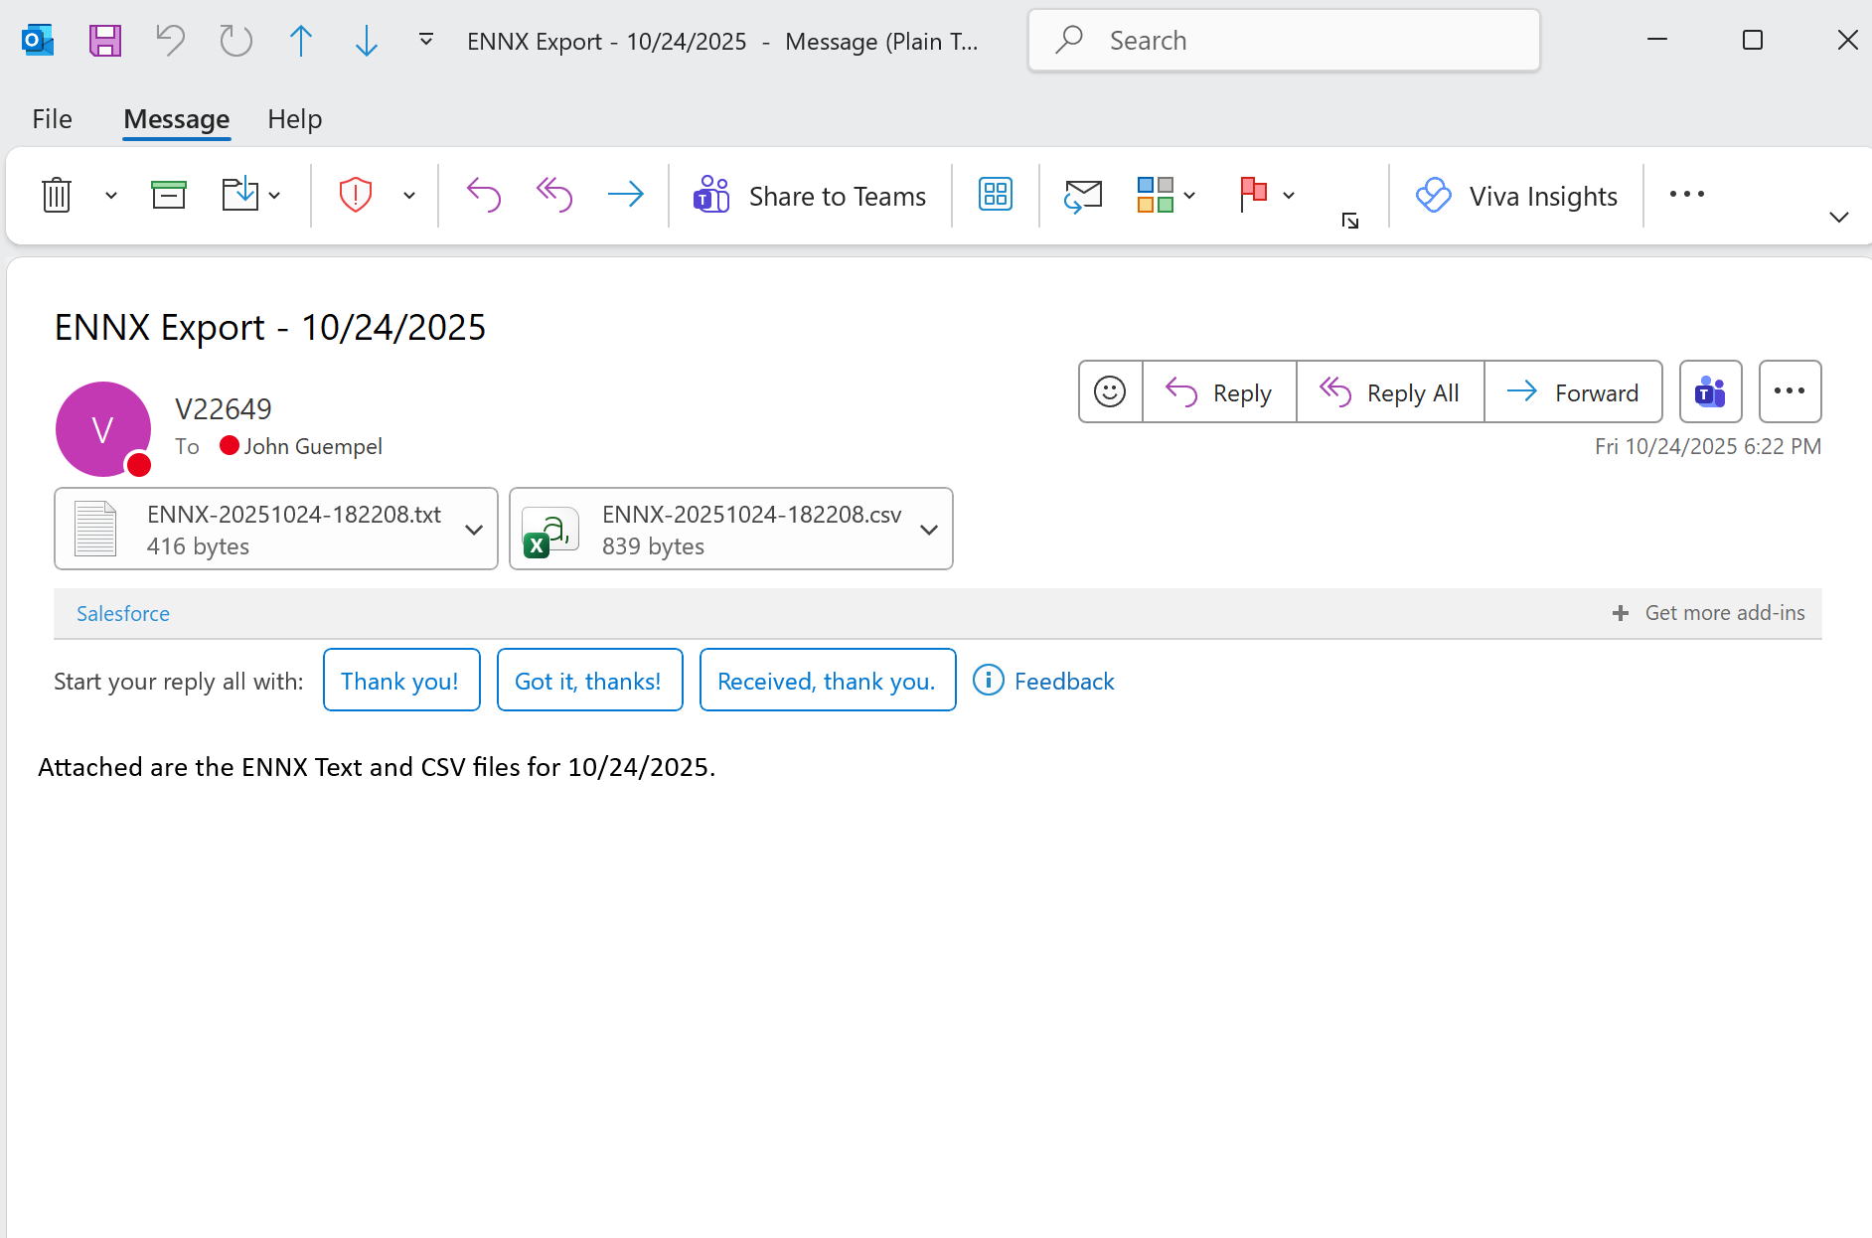

Opening the ENNX file you will notice it appears the same as you are used to seeing.

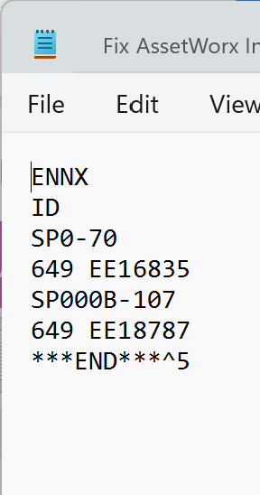
You will see this page. Click on “Tools”
Click this check mark and then click “Edit”

How to use Batch Mode Scanning
Batch Mode Scanning is used when you are visiting and doing Inventory/locates of assets where you will have no internet connection to the server.
- In AssetWorx, select “More”. Choose "Software Connectivity”, and tap where it says “Web Services”
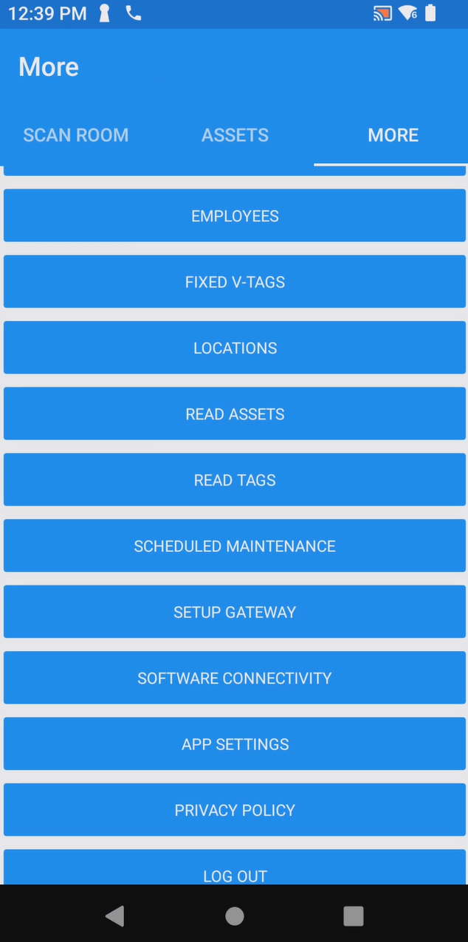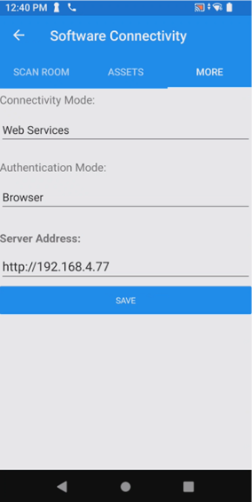

- Now tap “Batch Mode” on the pop-up. Then “Save”
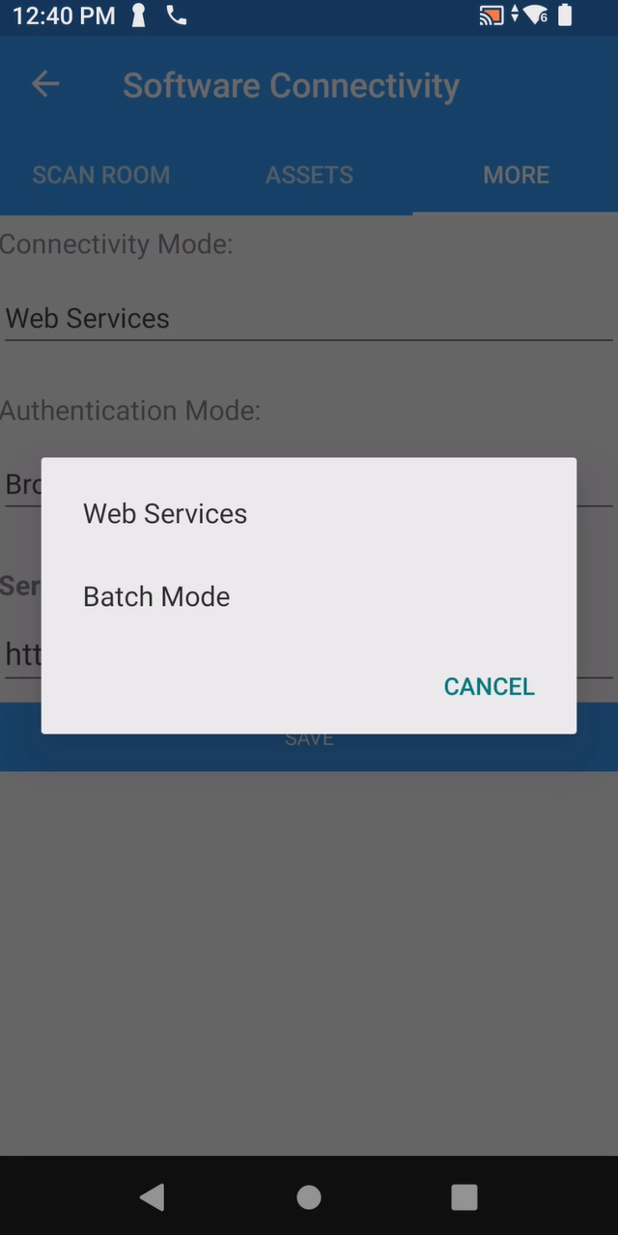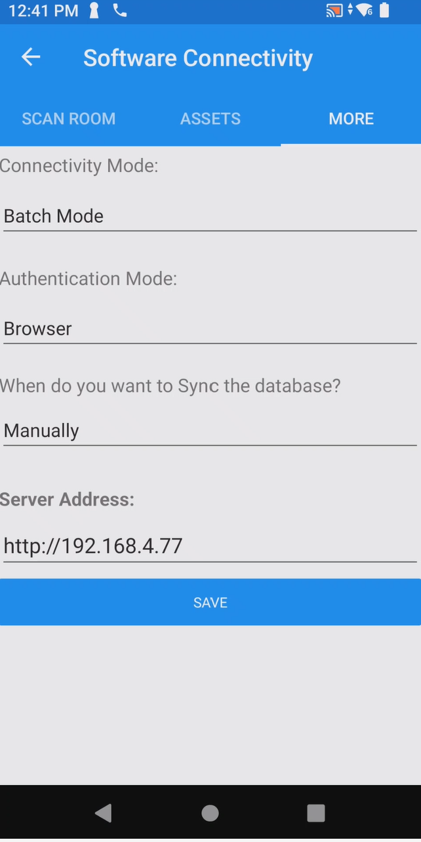

When prompted select “Yes” to sync with master database. This step will download your entire location and asset inventory from the server.

** If you are not prompted to Sync with the master database – proceed to the “Sync with the master database” section. It is important to do a sync app before, and immediately after your procedure so your data collected is retained.

- When prompted, enter the user and password. Prescott will use “649a” for each.
Now tap “Login”

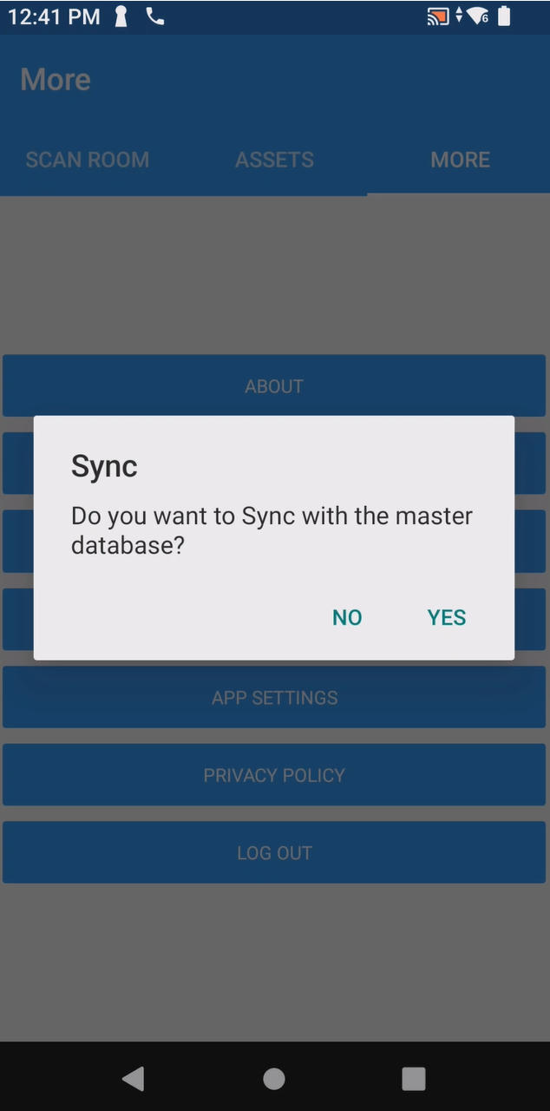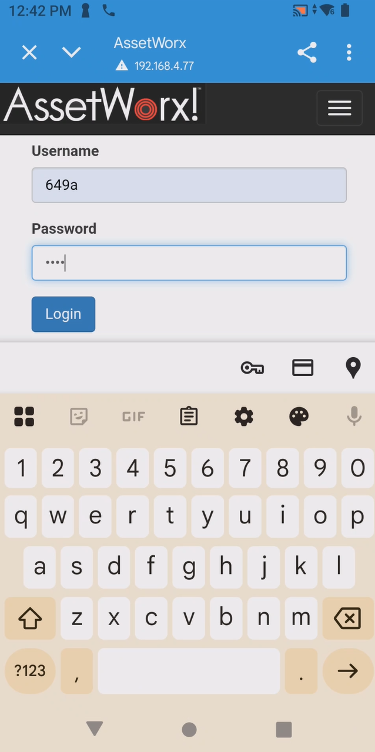
** Make sure you are near the print station when performing these actions.

At this point the RFID/Barcode reader will sync and you will see a screen like below indicating status.
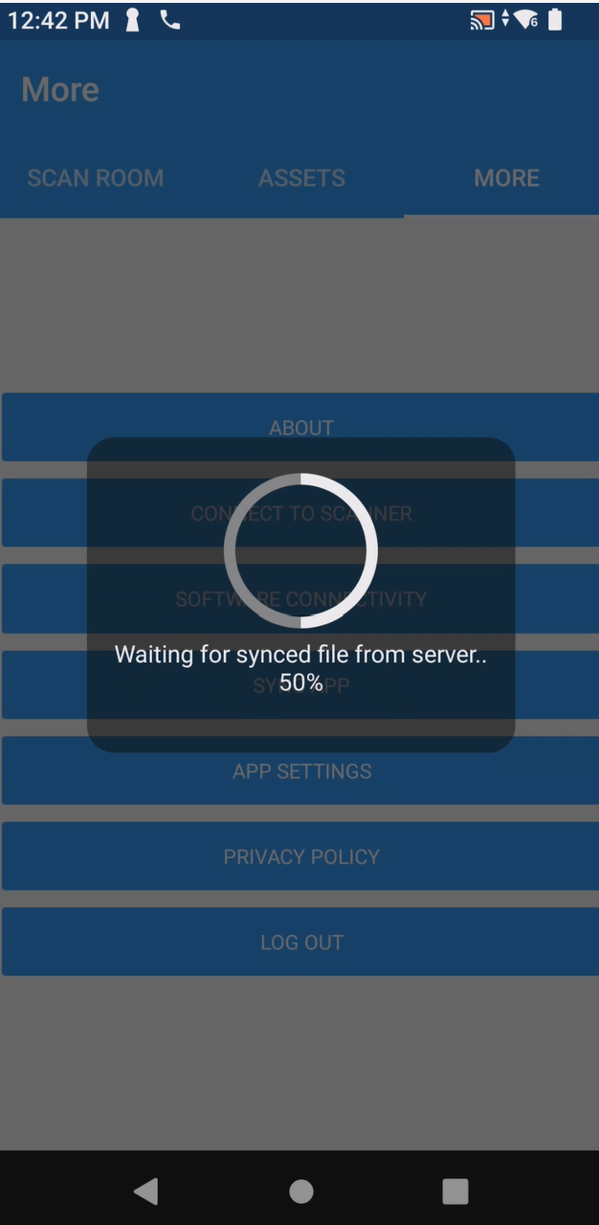
Be patient while reader sync’s with master database. This ensures your inventory is fully downloaded.

Now follow directions to scan location label and perform inventory/location as previously indicated. Proceed and do as many locations as necessary.
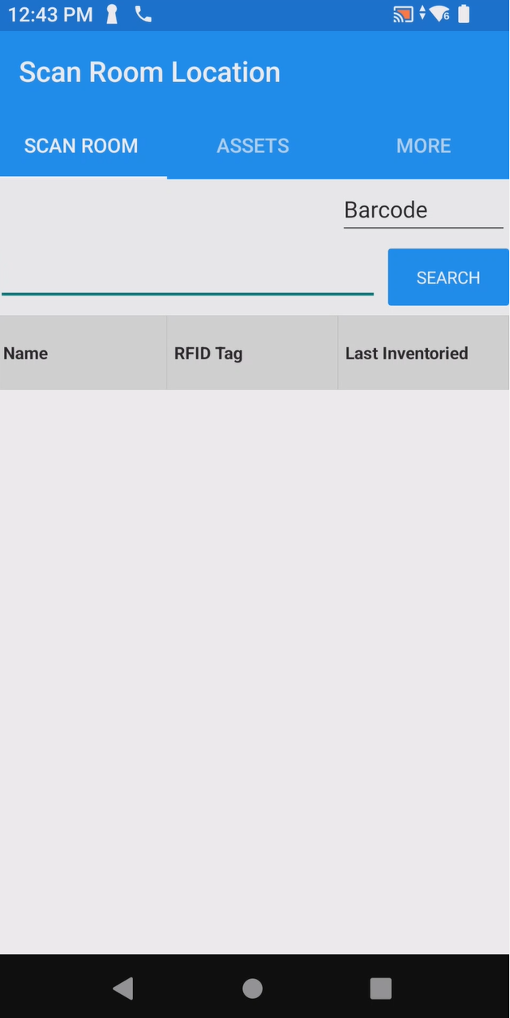
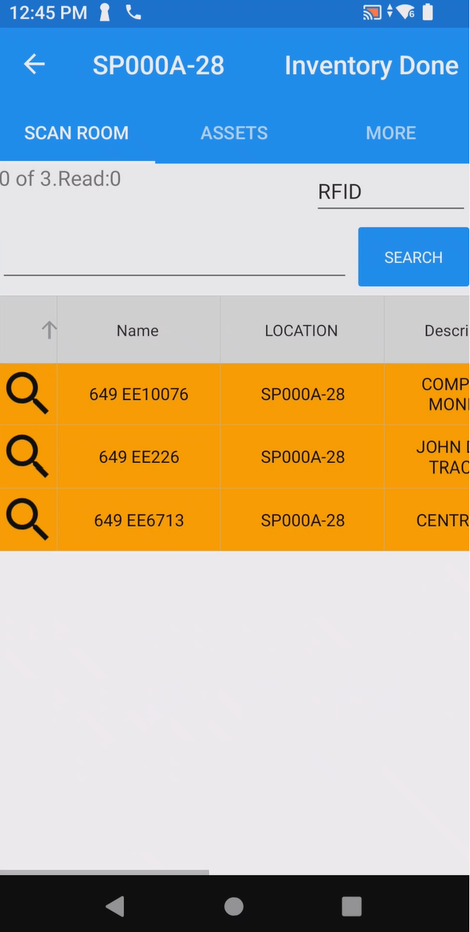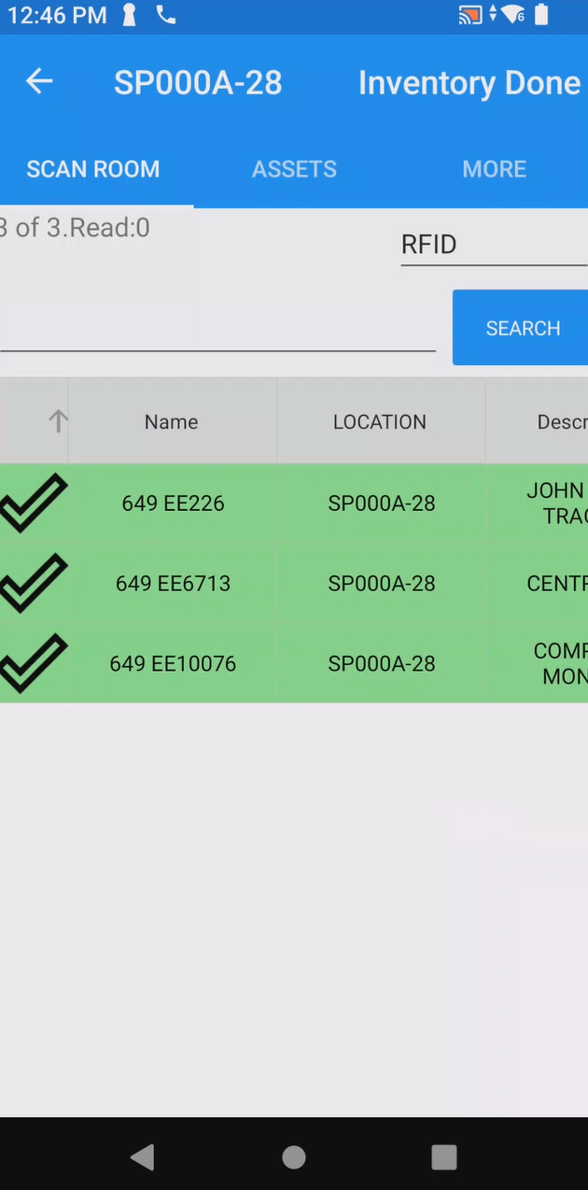

After you are done scanning it is very important to select “Inventory Done” and DO NOT CLOSE the application on the device. Immediately proceed to system and perform a sync app
Select Inventory Done before proceeding to the next location or completing your scans.
.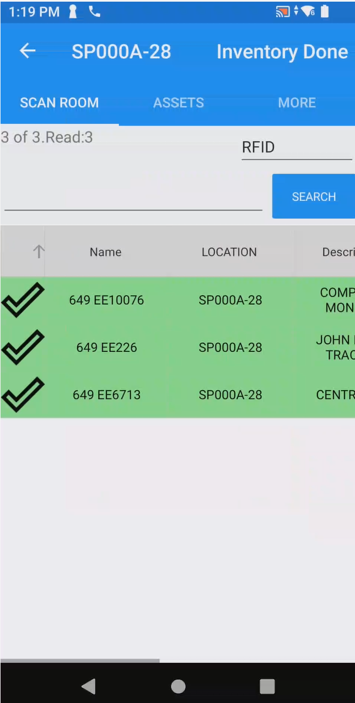
- After you return to the printing station area and you are successfully connected to the MiFi device, select “More” from the menu. Scroll down until you see “SYNC APP” and tap on it.
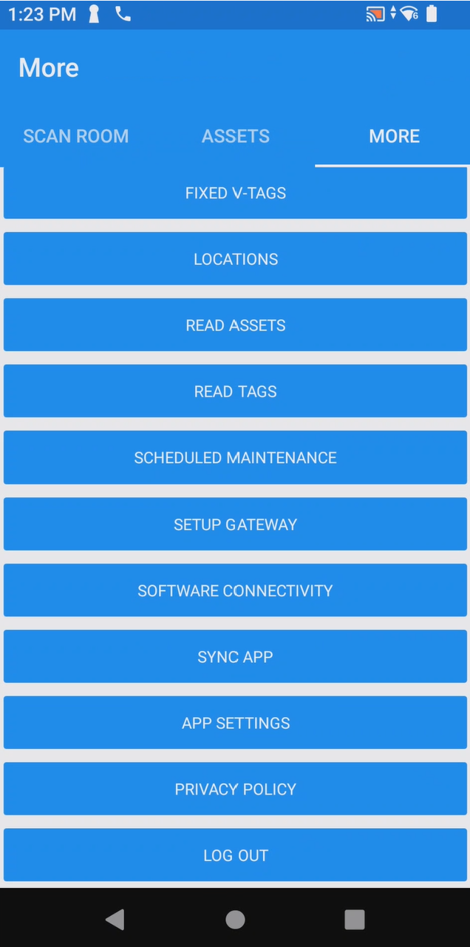
You will see the application ask to sync with the master database again, tap “Yes”. This will send your changes made offline to the server, then download a fully changed inventory to your device once again.
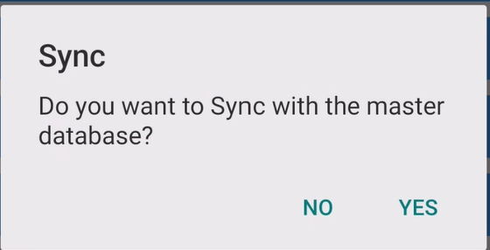

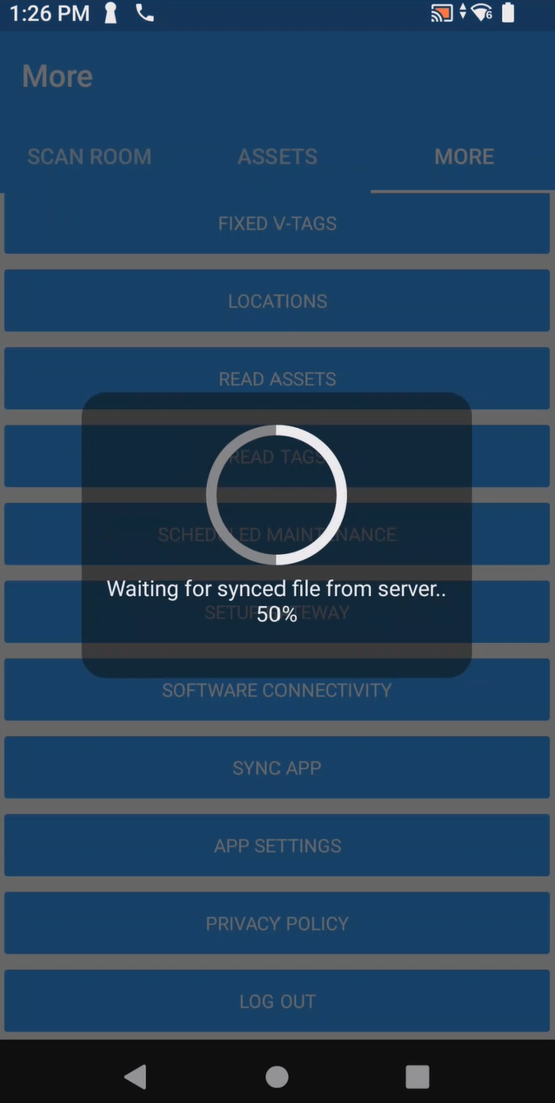

Lastly, go to the iDash site and email yourself the ENNX + Excel file.

